Preliminary ESP regressions

Abigail Tyrell

10 May 2021

# Black sea bass

Stock region: Mid

EPU: MAB, All, all, NE

# 1 Introduction

These are preliminary regressions that compare Mid Black sea bass catch, abundance, recruitment, and F to various indicators in the MAB, All, all, NE Environmental Protection Units (EPUs) taken from the ecodata package. The indicators are lagged by 0 years.

# 2 Regression analysis

All regressions are simple linear correlations assessed at the p < 0.5 level. Please note, due to the large number of indicators tested, a certain amount of statistically significant results are expected even if there are no underlying mechanistic connections. These correlations do not necessarily imply causation.

## 2.1 Trends with time

#### Figures

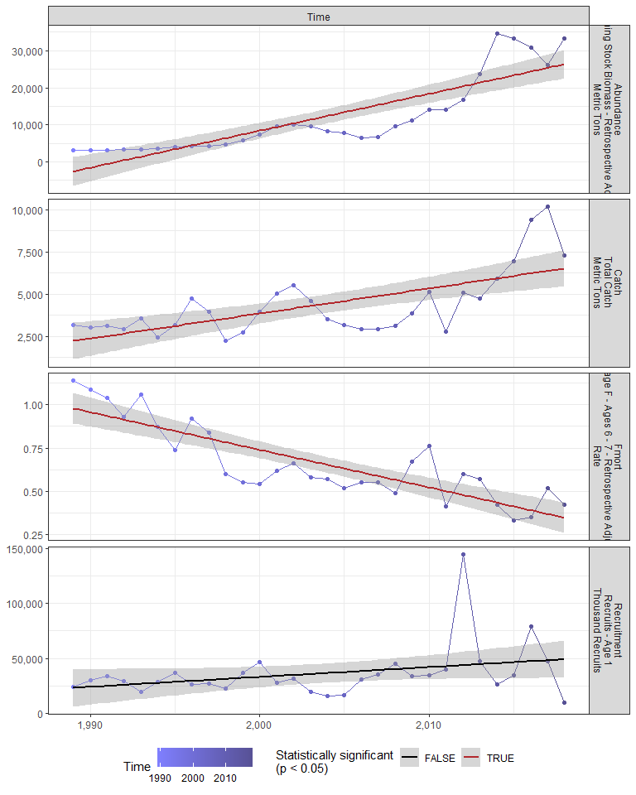

#### Regression statistics

Table 2.1: Catch vs Time

|  |  |  |  |  |
| --- | --- | --- | --- | --- |
|  | Estimate | Std. Error | t value | Pr(>|t|) |
| (Intercept) | -292860.65 | 62334.28 | -4.70 | 0 |
| Val | 148.36 | 31.11 | 4.77 | 0 |

|  |  |
| --- | --- |
| Name | Value |
| F-statistic | 22.74 |
| df | 1, 28 |
| R2 | 0.45 |
| R2-adj | 0.43 |

Table 2.1: Fmort vs Time

|  |  |  |  |  |
| --- | --- | --- | --- | --- |
|  | Estimate | Std. Error | t value | Pr(>|t|) |
| (Intercept) | 44.35 | 5.16 | 8.60 | 0 |
| Val | -0.02 | 0.00 | -8.47 | 0 |

|  |  |
| --- | --- |
| Name | Value |
| F-statistic | 71.72 |
| df | 1, 28 |
| R2 | 0.72 |
| R2-adj | 0.71 |

Table 2.1: Abundance vs Time

|  |  |  |  |  |
| --- | --- | --- | --- | --- |
|  | Estimate | Std. Error | t value | Pr(>|t|) |
| (Intercept) | -1986351.82 | 221985.0 | -8.95 | 0 |
| Val | 997.37 | 110.8 | 9.00 | 0 |

|  |  |
| --- | --- |
| Name | Value |
| F-statistic | 81.03 |
| df | 1, 28 |
| R2 | 0.74 |
| R2-adj | 0.73 |

## 2.2 Physical indicators

### 2.2.1 Cold pool index

#### Figures

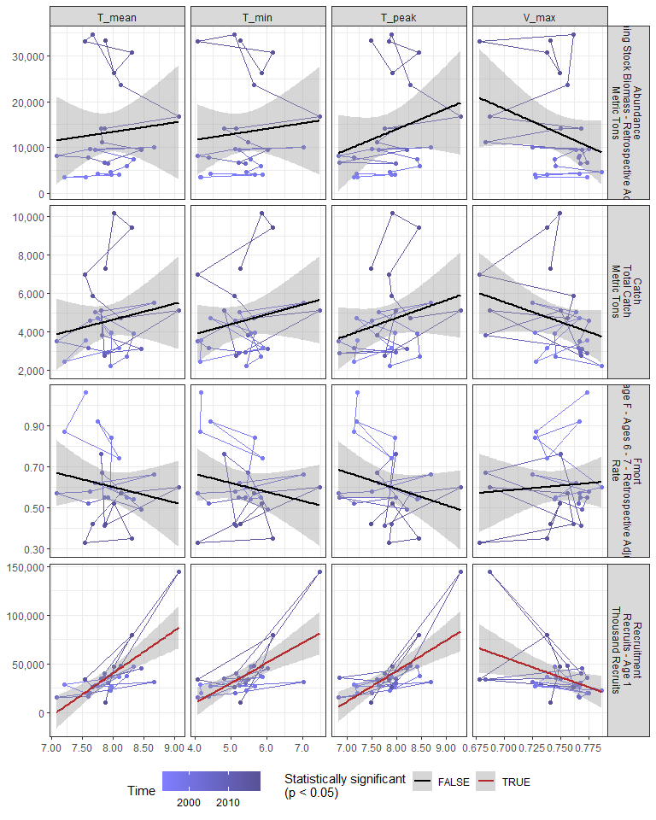

#### Regression statistics

Table 2.2: Recruitment vs T_mean

|  |  |  |  |  |
| --- | --- | --- | --- | --- |
|  | Estimate | Std. Error | t value | Pr(>|t|) |
| (Intercept) | -309857.00 | 68345.19 | -4.53 | 0 |
| Val | 43797.57 | 8613.65 | 5.08 | 0 |

|  |  |
| --- | --- |
| Name | Value |
| F-statistic | 25.85 |
| df | 1, 24 |
| R2 | 0.52 |
| R2-adj | 0.5 |

Table 2.2: Recruitment vs T_min

|  |  |  |  |  |
| --- | --- | --- | --- | --- |
|  | Estimate | Std. Error | t value | Pr(>|t|) |
| (Intercept) | -72267.28 | 24998.89 | -2.89 | 0.01 |
| Val | 20519.51 | 4631.38 | 4.43 | 0.00 |

|  |  |
| --- | --- |
| Name | Value |
| F-statistic | 19.63 |
| df | 1, 24 |
| R2 | 0.45 |
| R2-adj | 0.43 |

Table 2.2: Recruitment vs T_peak

|  |  |  |  |  |
| --- | --- | --- | --- | --- |
|  | Estimate | Std. Error | t value | Pr(>|t|) |
| (Intercept) | -208762.84 | 50062.90 | -4.17 | 0 |
| Val | 31410.13 | 6376.78 | 4.93 | 0 |

|  |  |
| --- | --- |
| Name | Value |
| F-statistic | 24.26 |
| df | 1, 24 |
| R2 | 0.5 |
| R2-adj | 0.48 |

Table 2.2: Recruitment vs V_max

|  |  |  |  |  |
| --- | --- | --- | --- | --- |
|  | Estimate | Std. Error | t value | Pr(>|t|) |
| (Intercept) | 343163.9 | 122104.1 | 2.81 | 0.01 |
| Val | -409413.3 | 163258.6 | -2.51 | 0.02 |

|  |  |
| --- | --- |
| Name | Value |
| F-statistic | 6.29 |
| df | 1, 24 |
| R2 | 0.21 |
| R2-adj | 0.17 |

### 2.2.2 Warm core rings

#### Figures

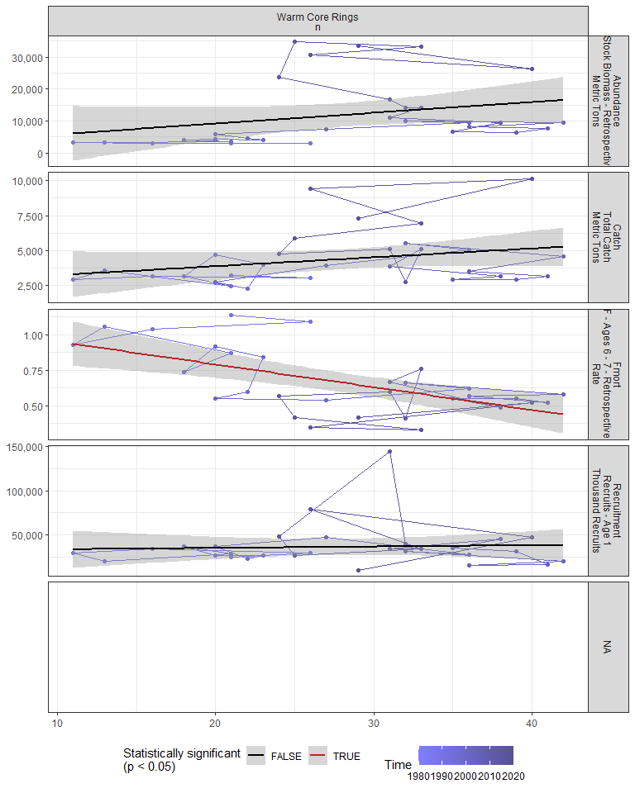

#### Regression statistics

Table 2.3: Fmort vs Warm Core Rings n

|  |  |  |  |  |
| --- | --- | --- | --- | --- |
|  | Estimate | Std. Error | t value | Pr(>|t|) |
| (Intercept) | 1.11 | 0.12 | 9.44 | 0 |
| Val | -0.02 | 0.00 | -3.97 | 0 |

|  |  |
| --- | --- |
| Name | Value |
| F-statistic | 15.8 |
| df | 1, 28 |
| R2 | 0.36 |
| R2-adj | 0.34 |

### 2.2.3 Marine heatwave index

#### Figures

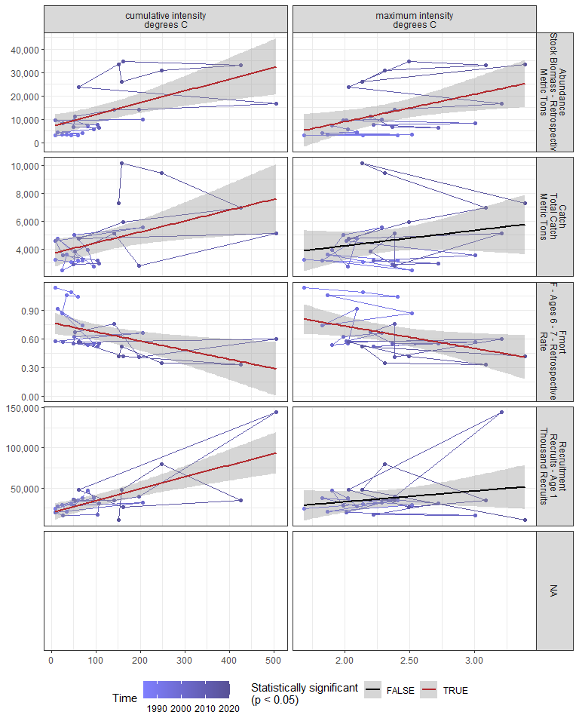

#### Regression statistics

Table 2.4: Catch vs cumulative intensity degrees C

|  |  |  |  |  |
| --- | --- | --- | --- | --- |
|  | Estimate | Std. Error | t value | Pr(>|t|) |
| (Intercept) | 3644.92 | 500.41 | 7.28 | 0.00 |
| Val | 7.82 | 2.97 | 2.63 | 0.01 |

|  |  |
| --- | --- |
| Name | Value |
| F-statistic | 6.93 |
| df | 1, 24 |
| R2 | 0.22 |
| R2-adj | 0.19 |

Table 2.4: Fmort vs cumulative intensity degrees C

|  |  |  |  |  |
| --- | --- | --- | --- | --- |
|  | Estimate | Std. Error | t value | Pr(>|t|) |
| (Intercept) | 0.77 | 0.06 | 13.57 | 0.00 |
| Val | 0.00 | 0.00 | -2.85 | 0.01 |

|  |  |
| --- | --- |
| Name | Value |
| F-statistic | 8.12 |
| df | 1, 24 |
| R2 | 0.25 |
| R2-adj | 0.22 |

Table 2.4: Fmort vs maximum intensity degrees C

|  |  |  |  |  |
| --- | --- | --- | --- | --- |
|  | Estimate | Std. Error | t value | Pr(>|t|) |
| (Intercept) | 1.20 | 0.23 | 5.22 | 0.00 |
| Val | -0.23 | 0.10 | -2.41 | 0.02 |

|  |  |
| --- | --- |
| Name | Value |
| F-statistic | 5.8 |
| df | 1, 24 |
| R2 | 0.19 |
| R2-adj | 0.16 |

Table 2.4: Recruitment vs cumulative intensity degrees C

|  |  |  |  |  |
| --- | --- | --- | --- | --- |
|  | Estimate | Std. Error | t value | Pr(>|t|) |
| (Intercept) | 19349.24 | 5217.65 | 3.71 | 0 |
| Val | 147.72 | 30.98 | 4.77 | 0 |

|  |  |
| --- | --- |
| Name | Value |
| F-statistic | 22.73 |
| df | 1, 24 |
| R2 | 0.49 |
| R2-adj | 0.46 |

Table 2.4: Abundance vs cumulative intensity degrees C

|  |  |  |  |  |
| --- | --- | --- | --- | --- |
|  | Estimate | Std. Error | t value | Pr(>|t|) |
| (Intercept) | 6796.69 | 2417.52 | 2.81 | 0.01 |
| Val | 51.04 | 14.36 | 3.56 | 0.00 |

|  |  |
| --- | --- |
| Name | Value |
| F-statistic | 12.64 |
| df | 1, 24 |
| R2 | 0.34 |
| R2-adj | 0.32 |

Table 2.4: Abundance vs maximum intensity degrees C

|  |  |  |  |  |
| --- | --- | --- | --- | --- |
|  | Estimate | Std. Error | t value | Pr(>|t|) |
| (Intercept) | -14400.68 | 10199.38 | -1.41 | 0.17 |
| Val | 11686.12 | 4299.27 | 2.72 | 0.01 |

|  |  |
| --- | --- |
| Name | Value |
| F-statistic | 7.39 |
| df | 1, 24 |
| R2 | 0.24 |
| R2-adj | 0.2 |

### 2.2.4 GLORYS bottom temperature

#### Figures

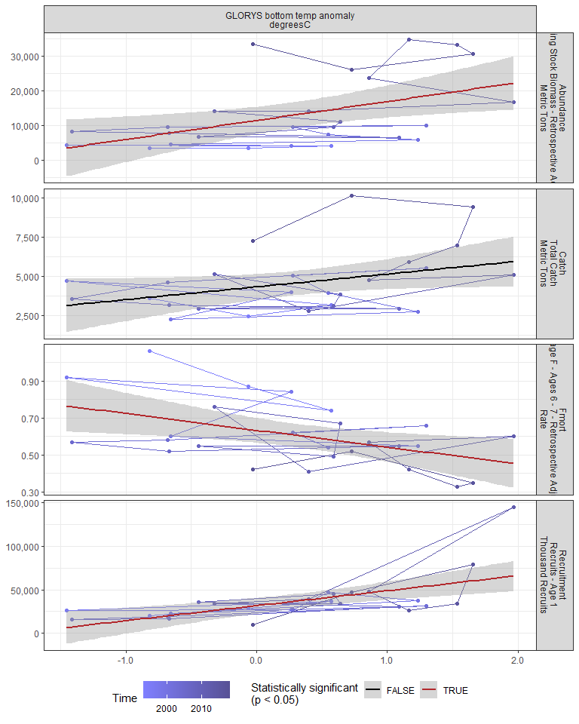

#### Regression statistics

Table 2.5: Fmort vs GLORYS bottom temp anomaly degreesC

|  |  |  |  |  |
| --- | --- | --- | --- | --- |
|  | Estimate | Std. Error | t value | Pr(>|t|) |
| (Intercept) | 0.63 | 0.03 | 19.34 | 0.00 |
| Val | -0.09 | 0.03 | -2.67 | 0.01 |

|  |  |
| --- | --- |
| Name | Value |
| F-statistic | 7.13 |
| df | 1, 24 |
| R2 | 0.23 |
| R2-adj | 0.2 |

Table 2.5: Recruitment vs GLORYS bottom temp anomaly degreesC

|  |  |  |  |  |
| --- | --- | --- | --- | --- |
|  | Estimate | Std. Error | t value | Pr(>|t|) |
| (Intercept) | 31705.22 | 4334.29 | 7.31 | 0 |
| Val | 17136.74 | 4496.85 | 3.81 | 0 |

|  |  |
| --- | --- |
| Name | Value |
| F-statistic | 14.52 |
| df | 1, 24 |
| R2 | 0.38 |
| R2-adj | 0.35 |

Table 2.5: Abundance vs GLORYS bottom temp anomaly degreesC

|  |  |  |  |  |
| --- | --- | --- | --- | --- |
|  | Estimate | Std. Error | t value | Pr(>|t|) |
| (Intercept) | 11467.48 | 1907.66 | 6.01 | 0.00 |
| Val | 5450.91 | 1979.21 | 2.75 | 0.01 |

|  |  |
| --- | --- |
| Name | Value |
| F-statistic | 7.59 |
| df | 1, 24 |
| R2 | 0.24 |
| R2-adj | 0.21 |

### 2.2.5 Long-term sea surface temperature

#### Figures

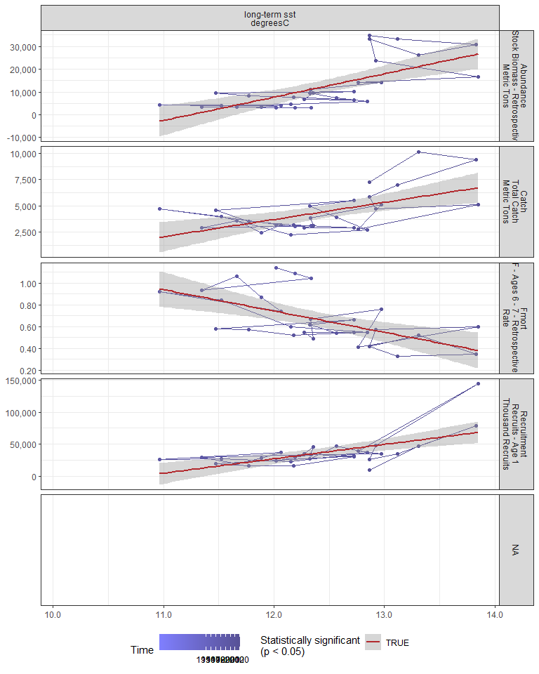

#### Regression statistics

Table 2.6: Catch vs long-term sst degreesC

|  |  |  |  |  |
| --- | --- | --- | --- | --- |
|  | Estimate | Std. Error | t value | Pr(>|t|) |
| (Intercept) | -15875.60 | 5495.74 | -2.89 | 0.01 |
| Val | 1632.12 | 442.31 | 3.69 | 0.00 |

|  |  |
| --- | --- |
| Name | Value |
| F-statistic | 13.62 |
| df | 1, 28 |
| R2 | 0.33 |
| R2-adj | 0.3 |

Table 2.6: Fmort vs long-term sst degreesC

|  |  |  |  |  |
| --- | --- | --- | --- | --- |
|  | Estimate | Std. Error | t value | Pr(>|t|) |
| (Intercept) | 3.09 | 0.63 | 4.92 | 0 |
| Val | -0.20 | 0.05 | -3.87 | 0 |

|  |  |
| --- | --- |
| Name | Value |
| F-statistic | 14.97 |
| df | 1, 28 |
| R2 | 0.35 |
| R2-adj | 0.33 |

Table 2.6: Recruitment vs long-term sst degreesC

|  |  |  |  |  |
| --- | --- | --- | --- | --- |
|  | Estimate | Std. Error | t value | Pr(>|t|) |
| (Intercept) | -242332.94 | 64356.61 | -3.77 | 0 |
| Val | 22443.81 | 5179.52 | 4.33 | 0 |

|  |  |
| --- | --- |
| Name | Value |
| F-statistic | 18.78 |
| df | 1, 28 |
| R2 | 0.4 |
| R2-adj | 0.38 |

Table 2.6: Abundance vs long-term sst degreesC

|  |  |  |  |  |
| --- | --- | --- | --- | --- |
|  | Estimate | Std. Error | t value | Pr(>|t|) |
| (Intercept) | -115373.65 | 25365.72 | -4.55 | 0 |
| Val | 10256.01 | 2041.47 | 5.02 | 0 |

|  |  |
| --- | --- |
| Name | Value |
| F-statistic | 25.24 |
| df | 1, 28 |
| R2 | 0.47 |
| R2-adj | 0.46 |

### 2.2.6 Sea surface temperature anomaly in EPU

#### Figures

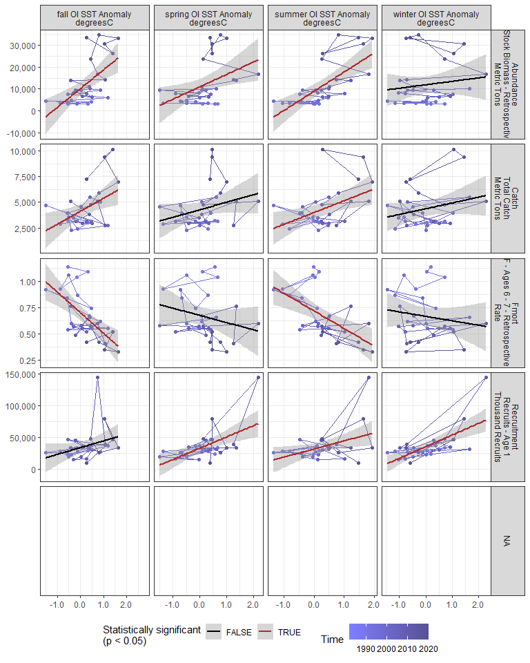

#### Regression statistics

Table 2.7: Catch vs fall OI SST Anomaly degreesC

|  |  |  |  |  |
| --- | --- | --- | --- | --- |
|  | Estimate | Std. Error | t value | Pr(>|t|) |
| (Intercept) | 4133.98 | 331.88 | 12.46 | 0.00 |
| Val | 1259.78 | 450.91 | 2.79 | 0.01 |

|  |  |
| --- | --- |
| Name | Value |
| F-statistic | 7.81 |
| df | 1, 28 |
| R2 | 0.22 |
| R2-adj | 0.19 |

Table 2.7: Catch vs summer OI SST Anomaly degreesC

|  |  |  |  |  |
| --- | --- | --- | --- | --- |
|  | Estimate | Std. Error | t value | Pr(>|t|) |
| (Intercept) | 3995.00 | 349.26 | 11.44 | 0.00 |
| Val | 1156.33 | 418.03 | 2.77 | 0.01 |

|  |  |
| --- | --- |
| Name | Value |
| F-statistic | 7.65 |
| df | 1, 28 |
| R2 | 0.21 |
| R2-adj | 0.19 |

Table 2.7: Fmort vs fall OI SST Anomaly degreesC

|  |  |  |  |  |
| --- | --- | --- | --- | --- |
|  | Estimate | Std. Error | t value | Pr(>|t|) |
| (Intercept) | 0.7 | 0.03 | 20.59 | 0 |
| Val | -0.2 | 0.05 | -4.22 | 0 |

|  |  |
| --- | --- |
| Name | Value |
| F-statistic | 17.81 |
| df | 1, 28 |
| R2 | 0.39 |
| R2-adj | 0.37 |

Table 2.7: Fmort vs summer OI SST Anomaly degreesC

|  |  |  |  |  |
| --- | --- | --- | --- | --- |
|  | Estimate | Std. Error | t value | Pr(>|t|) |
| (Intercept) | 0.72 | 0.04 | 19.36 | 0 |
| Val | -0.17 | 0.04 | -3.80 | 0 |

|  |  |
| --- | --- |
| Name | Value |
| F-statistic | 14.42 |
| df | 1, 28 |
| R2 | 0.34 |
| R2-adj | 0.32 |

Table 2.7: Recruitment vs summer OI SST Anomaly degreesC

|  |  |  |  |  |
| --- | --- | --- | --- | --- |
|  | Estimate | Std. Error | t value | Pr(>|t|) |
| (Intercept) | 31914.24 | 4452.19 | 7.17 | 0.00 |
| Val | 12852.17 | 5328.81 | 2.41 | 0.02 |

|  |  |
| --- | --- |
| Name | Value |
| F-statistic | 5.82 |
| df | 1, 28 |
| R2 | 0.17 |
| R2-adj | 0.14 |

Table 2.7: Recruitment vs spring OI SST Anomaly degreesC

|  |  |  |  |  |
| --- | --- | --- | --- | --- |
|  | Estimate | Std. Error | t value | Pr(>|t|) |
| (Intercept) | 33326.54 | 3758.16 | 8.87 | 0 |
| Val | 17714.73 | 4762.86 | 3.72 | 0 |

|  |  |
| --- | --- |
| Name | Value |
| F-statistic | 13.83 |
| df | 1, 28 |
| R2 | 0.33 |
| R2-adj | 0.31 |

Table 2.7: Recruitment vs winter OI SST Anomaly degreesC

|  |  |  |  |  |
| --- | --- | --- | --- | --- |
|  | Estimate | Std. Error | t value | Pr(>|t|) |
| (Intercept) | 35750.13 | 3271.20 | 10.93 | 0 |
| Val | 18263.95 | 3650.84 | 5.00 | 0 |

|  |  |
| --- | --- |
| Name | Value |
| F-statistic | 25.03 |
| df | 1, 28 |
| R2 | 0.47 |
| R2-adj | 0.45 |

Table 2.7: Abundance vs fall OI SST Anomaly degreesC

|  |  |  |  |  |
| --- | --- | --- | --- | --- |
|  | Estimate | Std. Error | t value | Pr(>|t|) |
| (Intercept) | 10237.42 | 1553.75 | 6.59 | 0 |
| Val | 8580.32 | 2110.98 | 4.06 | 0 |

|  |  |
| --- | --- |
| Name | Value |
| F-statistic | 16.52 |
| df | 1, 28 |
| R2 | 0.37 |
| R2-adj | 0.35 |

Table 2.7: Abundance vs summer OI SST Anomaly degreesC

|  |  |  |  |  |
| --- | --- | --- | --- | --- |
|  | Estimate | Std. Error | t value | Pr(>|t|) |
| (Intercept) | 8968.13 | 1508.55 | 5.94 | 0 |
| Val | 8860.24 | 1805.58 | 4.91 | 0 |

|  |  |
| --- | --- |
| Name | Value |
| F-statistic | 24.08 |
| df | 1, 28 |
| R2 | 0.46 |
| R2-adj | 0.44 |

Table 2.7: Abundance vs spring OI SST Anomaly degreesC

|  |  |  |  |  |
| --- | --- | --- | --- | --- |
|  | Estimate | Std. Error | t value | Pr(>|t|) |
| (Intercept) | 10974.53 | 1735.94 | 6.32 | 0.00 |
| Val | 5680.50 | 2200.03 | 2.58 | 0.02 |

|  |  |
| --- | --- |
| Name | Value |
| F-statistic | 6.67 |
| df | 1, 28 |
| R2 | 0.19 |
| R2-adj | 0.16 |

### 2.2.7 Sea surface temperature anomaly in stock region

#### Figures

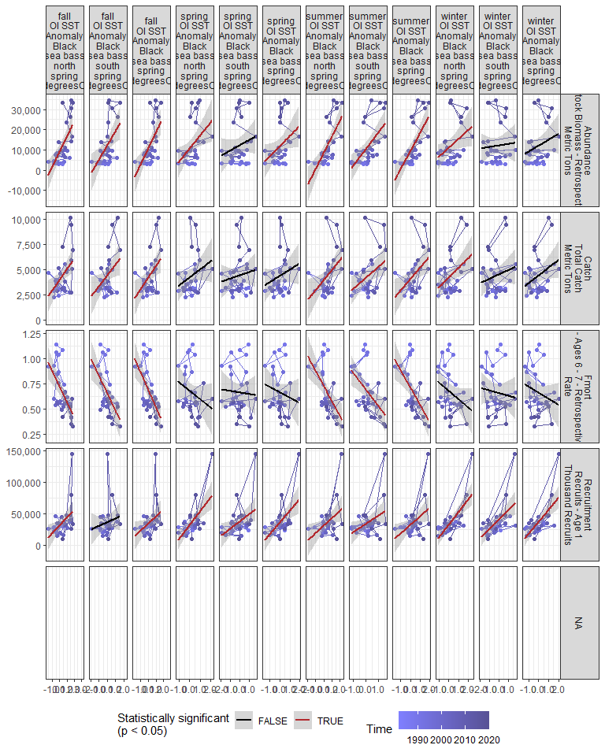

#### Regression statistics

Table 2.8: Catch vs fall OI SST Anomaly Black sea bass north spring degreesC

|  |  |  |  |  |
| --- | --- | --- | --- | --- |
|  | Estimate | Std. Error | t value | Pr(>|t|) |
| (Intercept) | 3985.82 | 345.41 | 11.54 | 0.00 |
| Val | 1047.06 | 362.51 | 2.89 | 0.01 |

|  |  |
| --- | --- |
| Name | Value |
| F-statistic | 8.34 |
| df | 1, 28 |
| R2 | 0.23 |
| R2-adj | 0.2 |

Table 2.8: Catch vs fall OI SST Anomaly Black sea bass south spring degreesC

|  |  |  |  |  |
| --- | --- | --- | --- | --- |
|  | Estimate | Std. Error | t value | Pr(>|t|) |
| (Intercept) | 4436.81 | 333.48 | 13.3 | 0.00 |
| Val | 1073.63 | 465.98 | 2.3 | 0.03 |

|  |  |
| --- | --- |
| Name | Value |
| F-statistic | 5.31 |
| df | 1, 28 |
| R2 | 0.16 |
| R2-adj | 0.13 |

Table 2.8: Catch vs fall OI SST Anomaly Black sea bass spring degreesC

|  |  |  |  |  |
| --- | --- | --- | --- | --- |
|  | Estimate | Std. Error | t value | Pr(>|t|) |
| (Intercept) | 4189.25 | 327.18 | 12.8 | 0.00 |
| Val | 1152.32 | 411.78 | 2.8 | 0.01 |

|  |  |
| --- | --- |
| Name | Value |
| F-statistic | 7.83 |
| df | 1, 28 |
| R2 | 0.22 |
| R2-adj | 0.19 |

Table 2.8: Catch vs summer OI SST Anomaly Black sea bass north spring degreesC

|  |  |  |  |  |
| --- | --- | --- | --- | --- |
|  | Estimate | Std. Error | t value | Pr(>|t|) |
| (Intercept) | 3946.43 | 365.94 | 10.78 | 0.00 |
| Val | 1001.75 | 389.36 | 2.57 | 0.02 |

|  |  |
| --- | --- |
| Name | Value |
| F-statistic | 6.62 |
| df | 1, 28 |
| R2 | 0.19 |
| R2-adj | 0.16 |

Table 2.8: Catch vs summer OI SST Anomaly Black sea bass south spring degreesC

|  |  |  |  |  |
| --- | --- | --- | --- | --- |
|  | Estimate | Std. Error | t value | Pr(>|t|) |
| (Intercept) | 4197.84 | 340.16 | 12.34 | 0.00 |
| Val | 1080.79 | 463.11 | 2.33 | 0.03 |

|  |  |
| --- | --- |
| Name | Value |
| F-statistic | 5.45 |
| df | 1, 28 |
| R2 | 0.16 |
| R2-adj | 0.13 |

Table 2.8: Catch vs summer OI SST Anomaly Black sea bass spring degreesC

|  |  |  |  |  |
| --- | --- | --- | --- | --- |
|  | Estimate | Std. Error | t value | Pr(>|t|) |
| (Intercept) | 4071.45 | 345.60 | 11.78 | 0.00 |
| Val | 1116.06 | 429.52 | 2.60 | 0.01 |

|  |  |
| --- | --- |
| Name | Value |
| F-statistic | 6.75 |
| df | 1, 28 |
| R2 | 0.19 |
| R2-adj | 0.17 |

Table 2.8: Catch vs winter OI SST Anomaly Black sea bass north spring degreesC

|  |  |  |  |  |
| --- | --- | --- | --- | --- |
|  | Estimate | Std. Error | t value | Pr(>|t|) |
| (Intercept) | 4202.55 | 334.21 | 12.57 | 0.00 |
| Val | 970.83 | 384.86 | 2.52 | 0.02 |

|  |  |
| --- | --- |
| Name | Value |
| F-statistic | 6.36 |
| df | 1, 28 |
| R2 | 0.19 |
| R2-adj | 0.16 |

Table 2.8: Fmort vs fall OI SST Anomaly Black sea bass north spring degreesC

|  |  |  |  |  |
| --- | --- | --- | --- | --- |
|  | Estimate | Std. Error | t value | Pr(>|t|) |
| (Intercept) | 0.72 | 0.04 | 19.79 | 0 |
| Val | -0.15 | 0.04 | -4.00 | 0 |

|  |  |
| --- | --- |
| Name | Value |
| F-statistic | 16.04 |
| df | 1, 28 |
| R2 | 0.36 |
| R2-adj | 0.34 |

Table 2.8: Fmort vs fall OI SST Anomaly Black sea bass south spring degreesC

|  |  |  |  |  |
| --- | --- | --- | --- | --- |
|  | Estimate | Std. Error | t value | Pr(>|t|) |
| (Intercept) | 0.65 | 0.04 | 18.67 | 0 |
| Val | -0.17 | 0.05 | -3.56 | 0 |

|  |  |
| --- | --- |
| Name | Value |
| F-statistic | 12.67 |
| df | 1, 28 |
| R2 | 0.31 |
| R2-adj | 0.29 |

Table 2.8: Fmort vs fall OI SST Anomaly Black sea bass spring degreesC

|  |  |  |  |  |
| --- | --- | --- | --- | --- |
|  | Estimate | Std. Error | t value | Pr(>|t|) |
| (Intercept) | 0.69 | 0.03 | 20.33 | 0 |
| Val | -0.17 | 0.04 | -4.07 | 0 |

|  |  |
| --- | --- |
| Name | Value |
| F-statistic | 16.6 |
| df | 1, 28 |
| R2 | 0.37 |
| R2-adj | 0.35 |

Table 2.8: Fmort vs summer OI SST Anomaly Black sea bass north spring degreesC

|  |  |  |  |  |
| --- | --- | --- | --- | --- |
|  | Estimate | Std. Error | t value | Pr(>|t|) |
| (Intercept) | 0.73 | 0.04 | 18.89 | 0 |
| Val | -0.15 | 0.04 | -3.73 | 0 |

|  |  |
| --- | --- |
| Name | Value |
| F-statistic | 13.89 |
| df | 1, 28 |
| R2 | 0.33 |
| R2-adj | 0.31 |

Table 2.8: Fmort vs summer OI SST Anomaly Black sea bass south spring degreesC

|  |  |  |  |  |
| --- | --- | --- | --- | --- |
|  | Estimate | Std. Error | t value | Pr(>|t|) |
| (Intercept) | 0.69 | 0.04 | 18.88 | 0 |
| Val | -0.16 | 0.05 | -3.31 | 0 |

|  |  |
| --- | --- |
| Name | Value |
| F-statistic | 10.95 |
| df | 1, 28 |
| R2 | 0.28 |
| R2-adj | 0.26 |

Table 2.8: Fmort vs summer OI SST Anomaly Black sea bass spring degreesC

|  |  |  |  |  |
| --- | --- | --- | --- | --- |
|  | Estimate | Std. Error | t value | Pr(>|t|) |
| (Intercept) | 0.71 | 0.04 | 19.51 | 0 |
| Val | -0.17 | 0.05 | -3.77 | 0 |

|  |  |
| --- | --- |
| Name | Value |
| F-statistic | 14.2 |
| df | 1, 28 |
| R2 | 0.34 |
| R2-adj | 0.31 |

Table 2.8: Recruitment vs fall OI SST Anomaly Black sea bass north spring degreesC

|  |  |  |  |  |
| --- | --- | --- | --- | --- |
|  | Estimate | Std. Error | t value | Pr(>|t|) |
| (Intercept) | 31554.50 | 4351.74 | 7.25 | 0.00 |
| Val | 12332.59 | 4567.15 | 2.70 | 0.01 |

|  |  |
| --- | --- |
| Name | Value |
| F-statistic | 7.29 |
| df | 1, 28 |
| R2 | 0.21 |
| R2-adj | 0.18 |

Table 2.8: Recruitment vs fall OI SST Anomaly Black sea bass spring degreesC

|  |  |  |  |  |
| --- | --- | --- | --- | --- |
|  | Estimate | Std. Error | t value | Pr(>|t|) |
| (Intercept) | 34333.50 | 4277.17 | 8.03 | 0.00 |
| Val | 11184.61 | 5383.01 | 2.08 | 0.05 |

|  |  |
| --- | --- |
| Name | Value |
| F-statistic | 4.32 |
| df | 1, 28 |
| R2 | 0.13 |
| R2-adj | 0.1 |

Table 2.8: Recruitment vs summer OI SST Anomaly Black sea bass north spring degreesC

|  |  |  |  |  |
| --- | --- | --- | --- | --- |
|  | Estimate | Std. Error | t value | Pr(>|t|) |
| (Intercept) | 31024.65 | 4583.89 | 6.77 | 0.00 |
| Val | 11953.24 | 4877.29 | 2.45 | 0.02 |

|  |  |
| --- | --- |
| Name | Value |
| F-statistic | 6.01 |
| df | 1, 28 |
| R2 | 0.18 |
| R2-adj | 0.15 |

Table 2.8: Recruitment vs summer OI SST Anomaly Black sea bass south spring degreesC

|  |  |  |  |  |
| --- | --- | --- | --- | --- |
|  | Estimate | Std. Error | t value | Pr(>|t|) |
| (Intercept) | 34000.61 | 4245.71 | 8.01 | 0.00 |
| Val | 13043.51 | 5780.24 | 2.26 | 0.03 |

|  |  |
| --- | --- |
| Name | Value |
| F-statistic | 5.09 |
| df | 1, 28 |
| R2 | 0.15 |
| R2-adj | 0.12 |

Table 2.8: Recruitment vs summer OI SST Anomaly Black sea bass spring degreesC

|  |  |  |  |  |
| --- | --- | --- | --- | --- |
|  | Estimate | Std. Error | t value | Pr(>|t|) |
| (Intercept) | 32501.53 | 4326.05 | 7.51 | 0.00 |
| Val | 13372.14 | 5376.47 | 2.49 | 0.02 |

|  |  |
| --- | --- |
| Name | Value |
| F-statistic | 6.19 |
| df | 1, 28 |
| R2 | 0.18 |
| R2-adj | 0.15 |

Table 2.8: Recruitment vs winter OI SST Anomaly Black sea bass north spring degreesC

|  |  |  |  |  |
| --- | --- | --- | --- | --- |
|  | Estimate | Std. Error | t value | Pr(>|t|) |
| (Intercept) | 32552.41 | 3178.17 | 10.24 | 0 |
| Val | 20235.21 | 3659.78 | 5.53 | 0 |

|  |  |
| --- | --- |
| Name | Value |
| F-statistic | 30.57 |
| df | 1, 28 |
| R2 | 0.52 |
| R2-adj | 0.5 |

Table 2.8: Recruitment vs spring OI SST Anomaly Black sea bass north spring degreesC

|  |  |  |  |  |
| --- | --- | --- | --- | --- |
|  | Estimate | Std. Error | t value | Pr(>|t|) |
| (Intercept) | 32100.66 | 3641.66 | 8.81 | 0 |
| Val | 21925.93 | 5182.48 | 4.23 | 0 |

|  |  |
| --- | --- |
| Name | Value |
| F-statistic | 17.9 |
| df | 1, 28 |
| R2 | 0.39 |
| R2-adj | 0.37 |

Table 2.8: Recruitment vs spring OI SST Anomaly Black sea bass south spring degreesC

|  |  |  |  |  |
| --- | --- | --- | --- | --- |
|  | Estimate | Std. Error | t value | Pr(>|t|) |
| (Intercept) | 37618.28 | 4123.85 | 9.12 | 0.00 |
| Val | 11366.81 | 4609.60 | 2.47 | 0.02 |

|  |  |
| --- | --- |
| Name | Value |
| F-statistic | 6.08 |
| df | 1, 28 |
| R2 | 0.18 |
| R2-adj | 0.15 |

Table 2.8: Recruitment vs spring OI SST Anomaly Black sea bass spring degreesC

|  |  |  |  |  |
| --- | --- | --- | --- | --- |
|  | Estimate | Std. Error | t value | Pr(>|t|) |
| (Intercept) | 36131.85 | 3724.43 | 9.70 | 0 |
| Val | 18633.00 | 5191.00 | 3.59 | 0 |

|  |  |
| --- | --- |
| Name | Value |
| F-statistic | 12.88 |
| df | 1, 28 |
| R2 | 0.32 |
| R2-adj | 0.29 |

Table 2.8: Recruitment vs winter OI SST Anomaly Black sea bass south spring degreesC

|  |  |  |  |  |
| --- | --- | --- | --- | --- |
|  | Estimate | Std. Error | t value | Pr(>|t|) |
| (Intercept) | 40684.64 | 3871.34 | 10.51 | 0 |
| Val | 14742.57 | 3940.39 | 3.74 | 0 |

|  |  |
| --- | --- |
| Name | Value |
| F-statistic | 14 |
| df | 1, 28 |
| R2 | 0.33 |
| R2-adj | 0.31 |

Table 2.8: Recruitment vs winter OI SST Anomaly Black sea bass spring degreesC

|  |  |  |  |  |
| --- | --- | --- | --- | --- |
|  | Estimate | Std. Error | t value | Pr(>|t|) |
| (Intercept) | 37223.24 | 3317.58 | 11.22 | 0 |
| Val | 18766.64 | 3849.64 | 4.87 | 0 |

|  |  |
| --- | --- |
| Name | Value |
| F-statistic | 23.76 |
| df | 1, 28 |
| R2 | 0.46 |
| R2-adj | 0.44 |

Table 2.8: Abundance vs fall OI SST Anomaly Black sea bass north spring degreesC

|  |  |  |  |  |
| --- | --- | --- | --- | --- |
|  | Estimate | Std. Error | t value | Pr(>|t|) |
| (Intercept) | 9117.50 | 1558.89 | 5.85 | 0 |
| Val | 7430.37 | 1636.06 | 4.54 | 0 |

|  |  |
| --- | --- |
| Name | Value |
| F-statistic | 20.63 |
| df | 1, 28 |
| R2 | 0.42 |
| R2-adj | 0.4 |

Table 2.8: Abundance vs fall OI SST Anomaly Black sea bass south spring degreesC

|  |  |  |  |  |
| --- | --- | --- | --- | --- |
|  | Estimate | Std. Error | t value | Pr(>|t|) |
| (Intercept) | 12288.98 | 1636.16 | 7.51 | 0 |
| Val | 7123.66 | 2286.26 | 3.12 | 0 |

|  |  |
| --- | --- |
| Name | Value |
| F-statistic | 9.71 |
| df | 1, 28 |
| R2 | 0.26 |
| R2-adj | 0.23 |

Table 2.8: Abundance vs fall OI SST Anomaly Black sea bass spring degreesC

|  |  |  |  |  |
| --- | --- | --- | --- | --- |
|  | Estimate | Std. Error | t value | Pr(>|t|) |
| (Intercept) | 10588.98 | 1512.94 | 7.0 | 0 |
| Val | 8003.52 | 1904.11 | 4.2 | 0 |

|  |  |
| --- | --- |
| Name | Value |
| F-statistic | 17.67 |
| df | 1, 28 |
| R2 | 0.39 |
| R2-adj | 0.36 |

Table 2.8: Abundance vs summer OI SST Anomaly Black sea bass north spring degreesC

|  |  |  |  |  |
| --- | --- | --- | --- | --- |
|  | Estimate | Std. Error | t value | Pr(>|t|) |
| (Intercept) | 8409.60 | 1560.79 | 5.39 | 0 |
| Val | 8112.25 | 1660.69 | 4.88 | 0 |

|  |  |
| --- | --- |
| Name | Value |
| F-statistic | 23.86 |
| df | 1, 28 |
| R2 | 0.46 |
| R2-adj | 0.44 |

Table 2.8: Abundance vs summer OI SST Anomaly Black sea bass south spring degreesC

|  |  |  |  |  |
| --- | --- | --- | --- | --- |
|  | Estimate | Std. Error | t value | Pr(>|t|) |
| (Intercept) | 10530.87 | 1569.06 | 6.71 | 0 |
| Val | 8229.20 | 2136.17 | 3.85 | 0 |

|  |  |
| --- | --- |
| Name | Value |
| F-statistic | 14.84 |
| df | 1, 28 |
| R2 | 0.35 |
| R2-adj | 0.32 |

Table 2.8: Abundance vs summer OI SST Anomaly Black sea bass spring degreesC

|  |  |  |  |  |
| --- | --- | --- | --- | --- |
|  | Estimate | Std. Error | t value | Pr(>|t|) |
| (Intercept) | 9474.98 | 1494.00 | 6.34 | 0 |
| Val | 8842.62 | 1856.76 | 4.76 | 0 |

|  |  |
| --- | --- |
| Name | Value |
| F-statistic | 22.68 |
| df | 1, 28 |
| R2 | 0.45 |
| R2-adj | 0.43 |

Table 2.8: Abundance vs winter OI SST Anomaly Black sea bass north spring degreesC

|  |  |  |  |  |
| --- | --- | --- | --- | --- |
|  | Estimate | Std. Error | t value | Pr(>|t|) |
| (Intercept) | 11086.85 | 1789.69 | 6.19 | 0.00 |
| Val | 4447.88 | 2060.89 | 2.16 | 0.04 |

|  |  |
| --- | --- |
| Name | Value |
| F-statistic | 4.66 |
| df | 1, 28 |
| R2 | 0.14 |
| R2-adj | 0.11 |

Table 2.8: Abundance vs spring OI SST Anomaly Black sea bass north spring degreesC

|  |  |  |  |  |
| --- | --- | --- | --- | --- |
|  | Estimate | Std. Error | t value | Pr(>|t|) |
| (Intercept) | 10677.03 | 1759.64 | 6.07 | 0.00 |
| Val | 6510.34 | 2504.16 | 2.60 | 0.01 |

|  |  |
| --- | --- |
| Name | Value |
| F-statistic | 6.76 |
| df | 1, 28 |
| R2 | 0.19 |
| R2-adj | 0.17 |

Table 2.8: Abundance vs spring OI SST Anomaly Black sea bass spring degreesC

|  |  |  |  |  |
| --- | --- | --- | --- | --- |
|  | Estimate | Std. Error | t value | Pr(>|t|) |
| (Intercept) | 11873.87 | 1764.71 | 6.73 | 0.00 |
| Val | 5040.02 | 2459.59 | 2.05 | 0.05 |

|  |  |
| --- | --- |
| Name | Value |
| F-statistic | 4.2 |
| df | 1, 28 |
| R2 | 0.13 |
| R2-adj | 0.1 |

### 2.2.8 Stratification

#### Figures

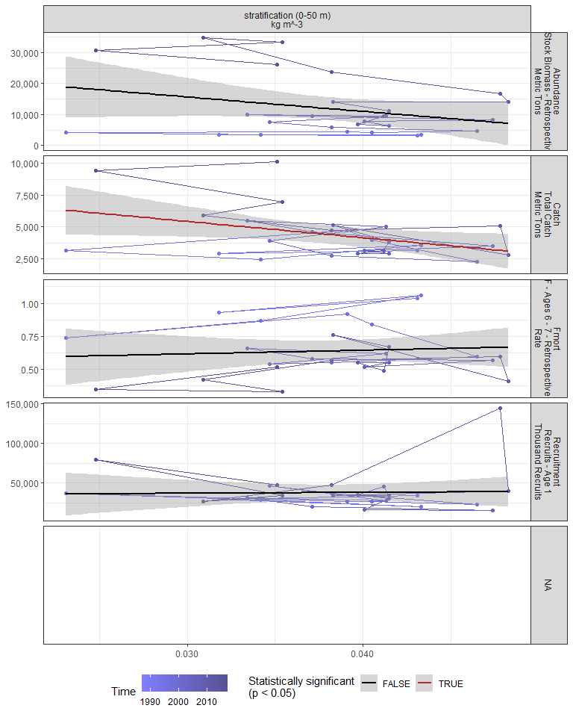

#### Regression statistics

Table 2.9: Catch vs stratification (0-50 m) kg m^-3

|  |  |  |  |  |
| --- | --- | --- | --- | --- |
|  | Estimate | Std. Error | t value | Pr(>|t|) |
| (Intercept) | 9270.54 | 2204.67 | 4.20 | 0.00 |
| Val | -127924.29 | 56707.01 | -2.26 | 0.03 |

|  |  |
| --- | --- |
| Name | Value |
| F-statistic | 5.09 |
| df | 1, 25 |
| R2 | 0.17 |
| R2-adj | 0.14 |

### 2.2.9 Winter wind speed

#### Figures

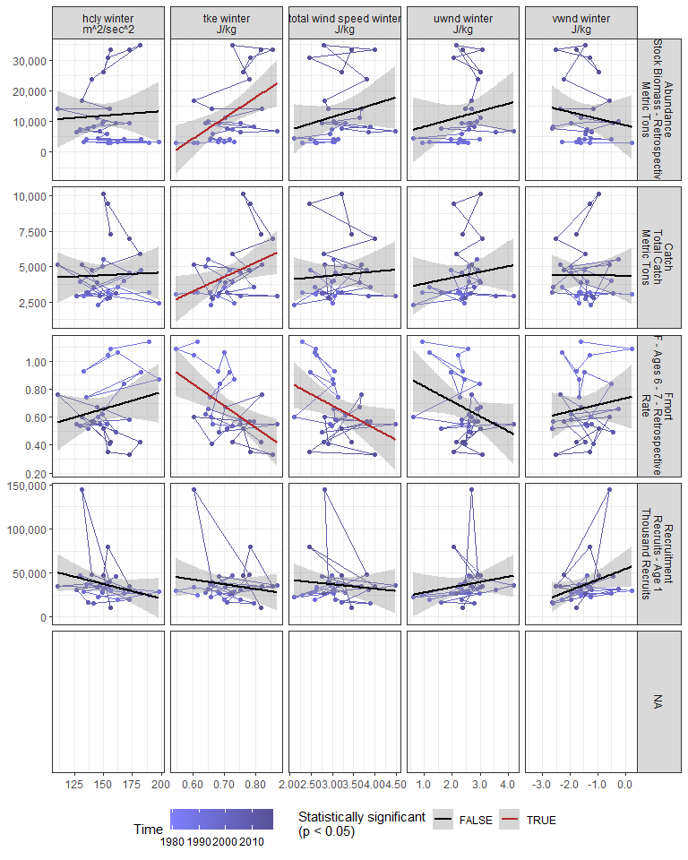

#### Regression statistics

Table 2.10: Catch vs tke winter J/kg

|  |  |  |  |  |
| --- | --- | --- | --- | --- |
|  | Estimate | Std. Error | t value | Pr(>|t|) |
| (Intercept) | -2908.65 | 3102.43 | -0.94 | 0.36 |
| Val | 10233.96 | 4334.77 | 2.36 | 0.03 |

|  |  |
| --- | --- |
| Name | Value |
| F-statistic | 5.57 |
| df | 1, 28 |
| R2 | 0.17 |
| R2-adj | 0.14 |

Table 2.10: Fmort vs tke winter J/kg

|  |  |  |  |  |
| --- | --- | --- | --- | --- |
|  | Estimate | Std. Error | t value | Pr(>|t|) |
| (Intercept) | 1.78 | 0.33 | 5.34 | 0 |
| Val | -1.56 | 0.46 | -3.36 | 0 |

|  |  |
| --- | --- |
| Name | Value |
| F-statistic | 11.31 |
| df | 1, 28 |
| R2 | 0.29 |
| R2-adj | 0.26 |

Table 2.10: Fmort vs total wind speed winter J/kg

|  |  |  |  |  |
| --- | --- | --- | --- | --- |
|  | Estimate | Std. Error | t value | Pr(>|t|) |
| (Intercept) | 1.17 | 0.22 | 5.22 | 0.00 |
| Val | -0.16 | 0.07 | -2.29 | 0.03 |

|  |  |
| --- | --- |
| Name | Value |
| F-statistic | 5.26 |
| df | 1, 28 |
| R2 | 0.16 |
| R2-adj | 0.13 |

Table 2.10: Abundance vs tke winter J/kg

|  |  |  |  |  |
| --- | --- | --- | --- | --- |
|  | Estimate | Std. Error | t value | Pr(>|t|) |
| (Intercept) | -35893.19 | 15234.91 | -2.36 | 0.03 |
| Val | 67122.49 | 21286.47 | 3.15 | 0.00 |

|  |  |
| --- | --- |
| Name | Value |
| F-statistic | 9.94 |
| df | 1, 28 |
| R2 | 0.26 |
| R2-adj | 0.24 |

### 2.2.10 Spring wind speed

#### Figures

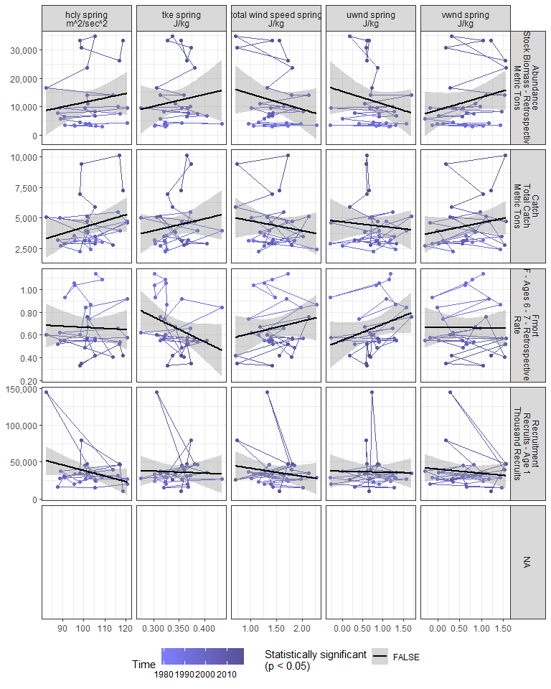

#### Regression statistics

[1] “No statistically significant data”

### 2.2.11 Summer wind speed

#### Figures

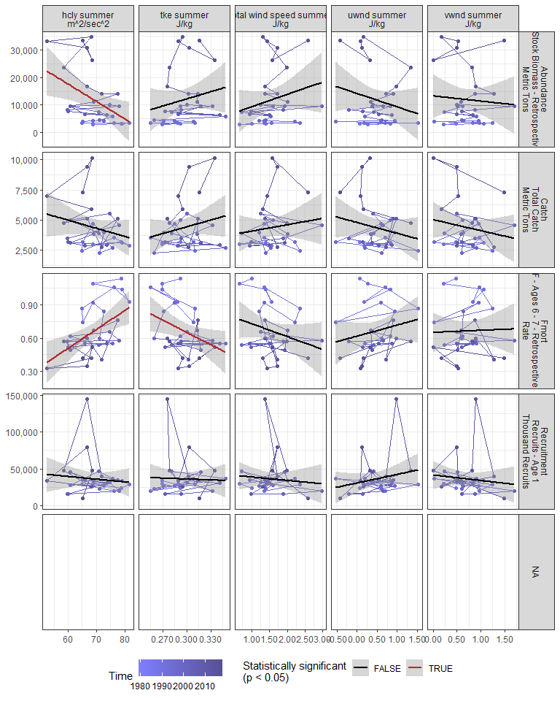

#### Regression statistics

Table 2.11: Fmort vs hcly summer m2/sec2

|  |  |  |  |  |
| --- | --- | --- | --- | --- |
|  | Estimate | Std. Error | t value | Pr(>|t|) |
| (Intercept) | -0.52 | 0.36 | -1.45 | 0.16 |
| Val | 0.02 | 0.01 | 3.32 | 0.00 |

|  |  |
| --- | --- |
| Name | Value |
| F-statistic | 11.04 |
| df | 1, 28 |
| R2 | 0.28 |
| R2-adj | 0.26 |

Table 2.11: Fmort vs tke summer J/kg

|  |  |  |  |  |
| --- | --- | --- | --- | --- |
|  | Estimate | Std. Error | t value | Pr(>|t|) |
| (Intercept) | 1.77 | 0.49 | 3.60 | 0.00 |
| Val | -3.72 | 1.65 | -2.25 | 0.03 |

|  |  |
| --- | --- |
| Name | Value |
| F-statistic | 5.07 |
| df | 1, 28 |
| R2 | 0.15 |
| R2-adj | 0.12 |

Table 2.11: Abundance vs hcly summer m2/sec2

|  |  |  |  |  |
| --- | --- | --- | --- | --- |
|  | Estimate | Std. Error | t value | Pr(>|t|) |
| (Intercept) | 55665.57 | 17073.09 | 3.26 | 0.00 |
| Val | -634.28 | 246.05 | -2.58 | 0.02 |

|  |  |
| --- | --- |
| Name | Value |
| F-statistic | 6.65 |
| df | 1, 28 |
| R2 | 0.19 |
| R2-adj | 0.16 |

### 2.2.12 Fall wind speed

#### Figures

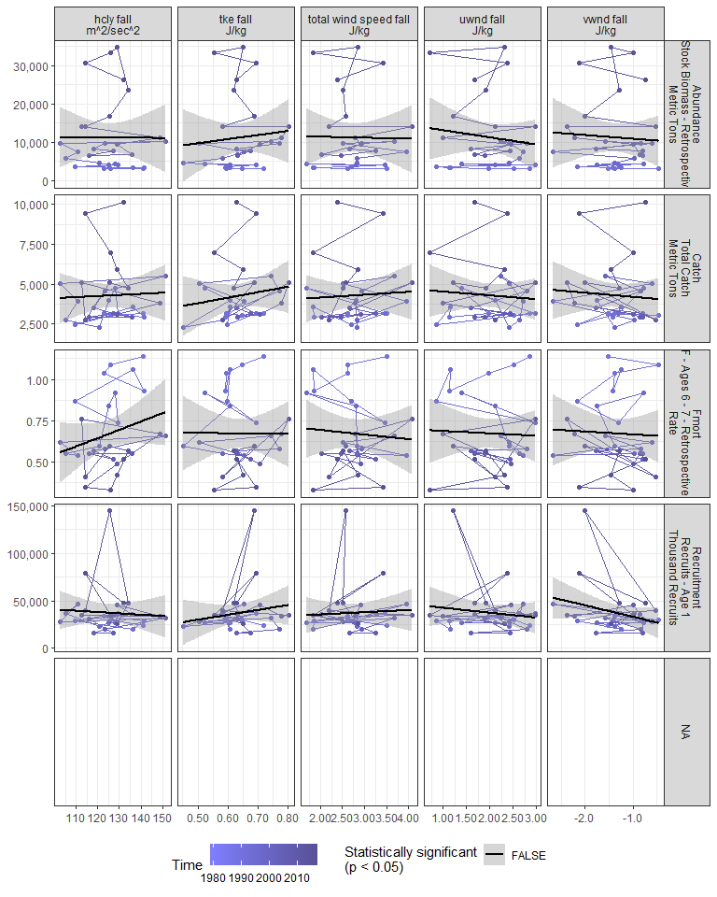

#### Regression statistics

[1] “No statistically significant data”

### 2.2.13 Gulf Stream Index

#### Figures

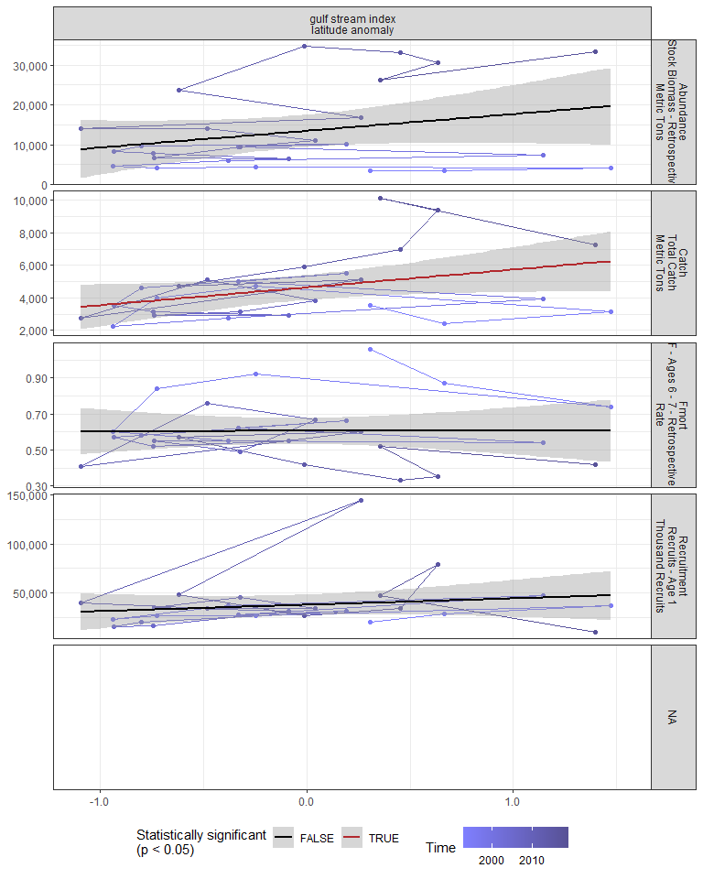

#### Regression statistics

Table 2.12: Catch vs gulf stream index latitude anomaly

|  |  |  |  |  |
| --- | --- | --- | --- | --- |
|  | Estimate | Std. Error | t value | Pr(>|t|) |
| (Intercept) | 4639.17 | 374.47 | 12.39 | 0.00 |
| Val | 1096.91 | 528.07 | 2.08 | 0.05 |

|  |  |
| --- | --- |
| Name | Value |
| F-statistic | 4.31 |
| df | 1, 24 |
| R2 | 0.15 |
| R2-adj | 0.12 |

### 2.2.14 North Atlantic Oscillation

#### Figures

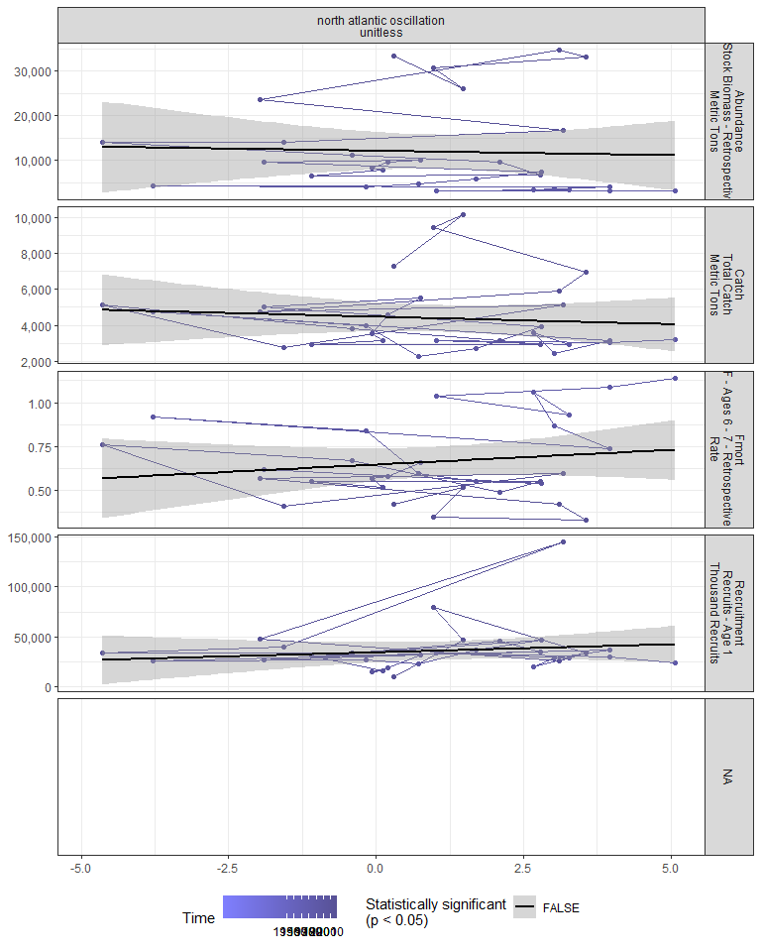

#### Regression statistics

[1] “No statistically significant data”

### 2.2.15 Northern range

Northernmost survey observation in each year.

#### Figures

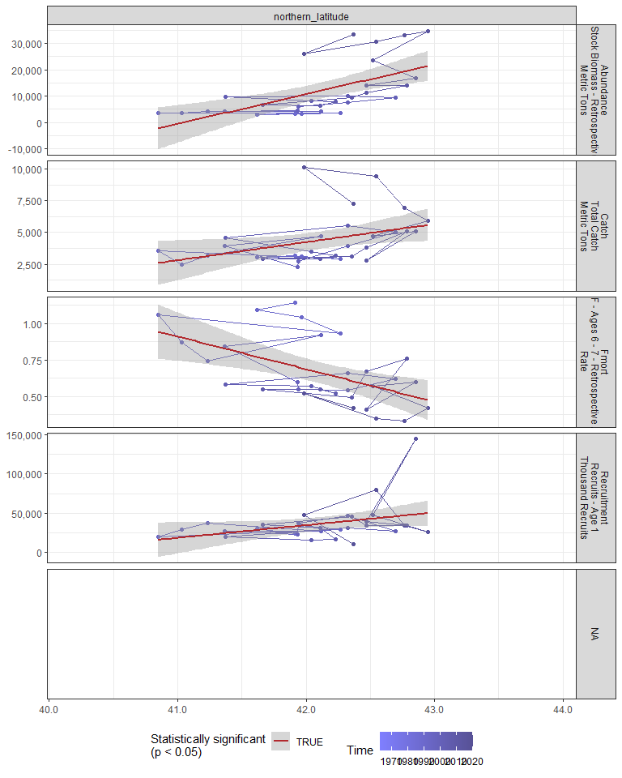

#### Regression statistics

Table 2.13: Catch vs northern_latitude

|  |  |  |  |  |
| --- | --- | --- | --- | --- |
|  | Estimate | Std. Error | t value | Pr(>|t|) |
| (Intercept) | -55715.69 | 26231.39 | -2.12 | 0.04 |
| Val | 1427.23 | 622.99 | 2.29 | 0.03 |

|  |  |
| --- | --- |
| Name | Value |
| F-statistic | 5.25 |
| df | 1, 28 |
| R2 | 0.16 |
| R2-adj | 0.13 |

Table 2.13: Fmort vs northern_latitude

|  |  |  |  |  |
| --- | --- | --- | --- | --- |
|  | Estimate | Std. Error | t value | Pr(>|t|) |
| (Intercept) | 10.07 | 2.80 | 3.60 | 0 |
| Val | -0.22 | 0.07 | -3.36 | 0 |

|  |  |
| --- | --- |
| Name | Value |
| F-statistic | 11.28 |
| df | 1, 28 |
| R2 | 0.29 |
| R2-adj | 0.26 |

Table 2.13: Recruitment vs northern_latitude

|  |  |  |  |  |
| --- | --- | --- | --- | --- |
|  | Estimate | Std. Error | t value | Pr(>|t|) |
| (Intercept) | -643401.13 | 330822.15 | -1.94 | 0.06 |
| Val | 16139.92 | 7856.94 | 2.05 | 0.05 |

|  |  |
| --- | --- |
| Name | Value |
| F-statistic | 4.22 |
| df | 1, 28 |
| R2 | 0.13 |
| R2-adj | 0.1 |

Table 2.13: Abundance vs northern_latitude

|  |  |  |  |  |
| --- | --- | --- | --- | --- |
|  | Estimate | Std. Error | t value | Pr(>|t|) |
| (Intercept) | -463707.94 | 119113.65 | -3.89 | 0 |
| Val | 11295.82 | 2828.92 | 3.99 | 0 |

|  |  |
| --- | --- |
| Name | Value |
| F-statistic | 15.94 |
| df | 1, 28 |
| R2 | 0.36 |
| R2-adj | 0.34 |

### 2.2.16 Southern range

Southernmost survey observation in each year.

#### Figures

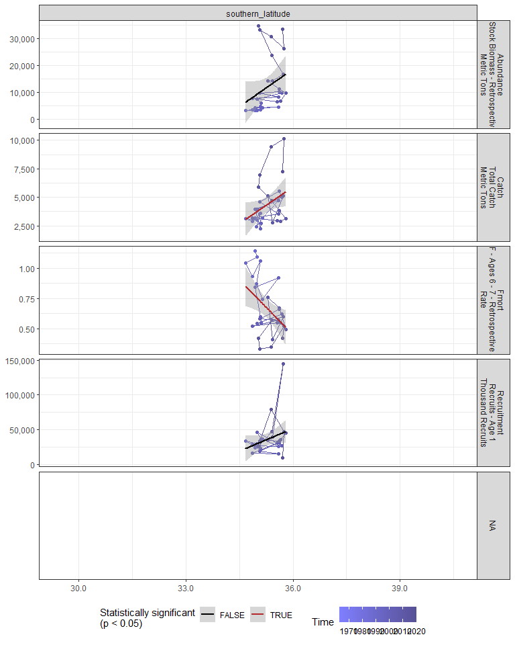

#### Regression statistics

Table 2.14: Catch vs southern_latitude

|  |  |  |  |  |
| --- | --- | --- | --- | --- |
|  | Estimate | Std. Error | t value | Pr(>|t|) |
| (Intercept) | -71418.84 | 36351.22 | -1.96 | 0.06 |
| Val | 2148.09 | 1030.20 | 2.09 | 0.05 |

|  |  |
| --- | --- |
| Name | Value |
| F-statistic | 4.35 |
| df | 1, 28 |
| R2 | 0.13 |
| R2-adj | 0.1 |

Table 2.14: Fmort vs southern_latitude

|  |  |  |  |  |
| --- | --- | --- | --- | --- |
|  | Estimate | Std. Error | t value | Pr(>|t|) |
| (Intercept) | 11.32 | 4.06 | 2.79 | 0.01 |
| Val | -0.30 | 0.12 | -2.62 | 0.01 |

|  |  |
| --- | --- |
| Name | Value |
| F-statistic | 6.88 |
| df | 1, 28 |
| R2 | 0.2 |
| R2-adj | 0.17 |

## 2.3 Trophic indicators

### 2.3.1 Chlorophyll

#### Figures

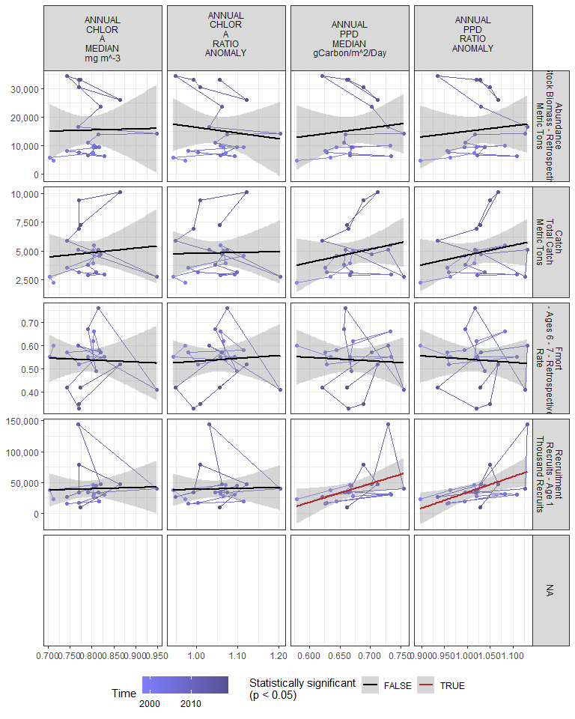

#### Regression statistics

Table 2.15: Recruitment vs ANNUAL PPD MEDIAN gCarbon/m^2/Day

|  |  |  |  |  |
| --- | --- | --- | --- | --- |
|  | Estimate | Std. Error | t value | Pr(>|t|) |
| (Intercept) | -163192.6 | 88337.88 | -1.85 | 0.08 |
| Val | 301760.6 | 131306.96 | 2.30 | 0.03 |

|  |  |
| --- | --- |
| Name | Value |
| F-statistic | 5.28 |
| df | 1, 19 |
| R2 | 0.22 |
| R2-adj | 0.18 |

Table 2.15: Recruitment vs ANNUAL PPD RATIO ANOMALY

|  |  |  |  |  |
| --- | --- | --- | --- | --- |
|  | Estimate | Std. Error | t value | Pr(>|t|) |
| (Intercept) | -222071.3 | 91655.99 | -2.42 | 0.03 |
| Val | 255939.5 | 89563.21 | 2.86 | 0.01 |

|  |  |
| --- | --- |
| Name | Value |
| F-statistic | 8.17 |
| df | 1, 19 |
| R2 | 0.3 |
| R2-adj | 0.26 |

### 2.3.2 Chlorophyll in stock region

#### Figures

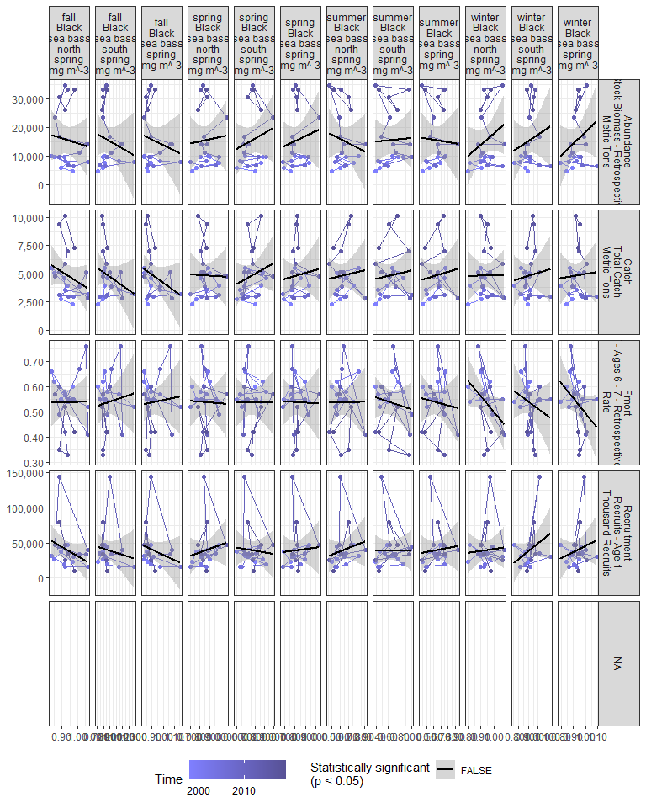

#### Regression statistics

[1] “No statistically significant data”

### 2.3.3 Primary production in stock region

#### Figures

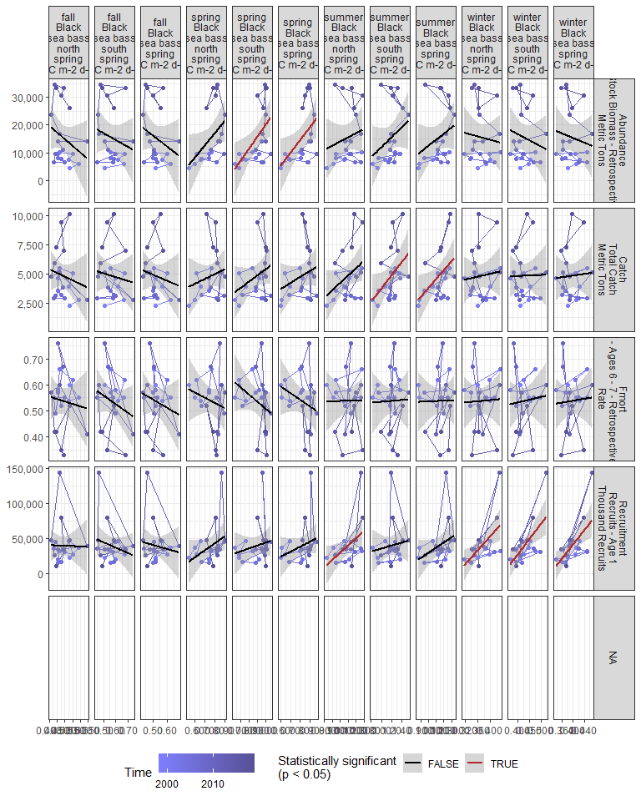

#### Regression statistics

Table 2.16: Catch vs summer Black sea bass south spring gC m-2 d-1

|  |  |  |  |  |
| --- | --- | --- | --- | --- |
|  | Estimate | Std. Error | t value | Pr(>|t|) |
| (Intercept) | -1912.50 | 3091.35 | -0.62 | 0.54 |
| Val | 5657.88 | 2575.54 | 2.20 | 0.04 |

|  |  |
| --- | --- |
| Name | Value |
| F-statistic | 4.83 |
| df | 1, 19 |
| R2 | 0.2 |
| R2-adj | 0.16 |

Table 2.16: Catch vs summer Black sea bass spring gC m-2 d-1

|  |  |  |  |  |
| --- | --- | --- | --- | --- |
|  | Estimate | Std. Error | t value | Pr(>|t|) |
| (Intercept) | -3737.76 | 3773.84 | -0.99 | 0.33 |
| Val | 7537.48 | 3305.55 | 2.28 | 0.03 |

|  |  |
| --- | --- |
| Name | Value |
| F-statistic | 5.2 |
| df | 1, 19 |
| R2 | 0.21 |
| R2-adj | 0.17 |

Table 2.16: Recruitment vs summer Black sea bass north spring gC m-2 d-1

|  |  |  |  |  |
| --- | --- | --- | --- | --- |
|  | Estimate | Std. Error | t value | Pr(>|t|) |
| (Intercept) | -73614.5 | 47979.48 | -1.53 | 0.14 |
| Val | 103349.9 | 43575.90 | 2.37 | 0.03 |

|  |  |
| --- | --- |
| Name | Value |
| F-statistic | 5.63 |
| df | 1, 19 |
| R2 | 0.23 |
| R2-adj | 0.19 |

Table 2.16: Recruitment vs winter Black sea bass north spring gC m-2 d-1

|  |  |  |  |  |
| --- | --- | --- | --- | --- |
|  | Estimate | Std. Error | t value | Pr(>|t|) |
| (Intercept) | -151495.7 | 61575.77 | -2.46 | 0.02 |
| Val | 512875.8 | 164843.57 | 3.11 | 0.01 |

|  |  |
| --- | --- |
| Name | Value |
| F-statistic | 9.68 |
| df | 1, 19 |
| R2 | 0.34 |
| R2-adj | 0.3 |

Table 2.16: Recruitment vs winter Black sea bass south spring gC m-2 d-1

|  |  |  |  |  |
| --- | --- | --- | --- | --- |
|  | Estimate | Std. Error | t value | Pr(>|t|) |
| (Intercept) | -143339.3 | 51208.42 | -2.80 | 0.01 |
| Val | 428072.1 | 119400.71 | 3.59 | 0.00 |

|  |  |
| --- | --- |
| Name | Value |
| F-statistic | 12.85 |
| df | 1, 19 |
| R2 | 0.4 |
| R2-adj | 0.37 |

Table 2.16: Recruitment vs winter Black sea bass spring gC m-2 d-1

|  |  |  |  |  |
| --- | --- | --- | --- | --- |
|  | Estimate | Std. Error | t value | Pr(>|t|) |
| (Intercept) | -159017.1 | 57005.81 | -2.79 | 0.01 |
| Val | 501499.8 | 143531.31 | 3.49 | 0.00 |

|  |  |
| --- | --- |
| Name | Value |
| F-statistic | 12.21 |
| df | 1, 19 |
| R2 | 0.39 |
| R2-adj | 0.36 |

Table 2.16: Abundance vs spring Black sea bass south spring gC m-2 d-1

|  |  |  |  |  |
| --- | --- | --- | --- | --- |
|  | Estimate | Std. Error | t value | Pr(>|t|) |
| (Intercept) | -23201.68 | 14110.66 | -1.64 | 0.12 |
| Val | 43356.71 | 15686.71 | 2.76 | 0.01 |

|  |  |
| --- | --- |
| Name | Value |
| F-statistic | 7.64 |
| df | 1, 19 |
| R2 | 0.29 |
| R2-adj | 0.25 |

Table 2.16: Abundance vs spring Black sea bass spring gC m-2 d-1

|  |  |  |  |  |
| --- | --- | --- | --- | --- |
|  | Estimate | Std. Error | t value | Pr(>|t|) |
| (Intercept) | -22891.02 | 15703.82 | -1.46 | 0.16 |
| Val | 46924.99 | 19073.96 | 2.46 | 0.02 |

|  |  |
| --- | --- |
| Name | Value |
| F-statistic | 6.05 |
| df | 1, 19 |
| R2 | 0.24 |
| R2-adj | 0.2 |

### 2.3.4 Spring zooplankton abundance by species

#### Figures

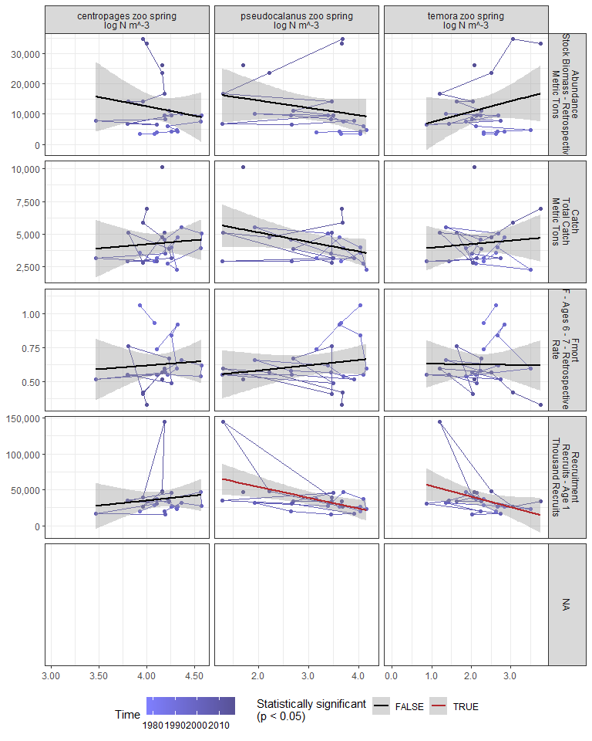

#### Regression statistics

Table 2.17: Recruitment vs pseudocalanus zoo spring log N m^-3

|  |  |  |  |  |
| --- | --- | --- | --- | --- |
|  | Estimate | Std. Error | t value | Pr(>|t|) |
| (Intercept) | 84209.86 | 16502.62 | 5.10 | 0.00 |
| Val | -15156.51 | 5061.63 | -2.99 | 0.01 |

|  |  |
| --- | --- |
| Name | Value |
| F-statistic | 8.97 |
| df | 1, 22 |
| R2 | 0.29 |
| R2-adj | 0.26 |

Table 2.17: Recruitment vs temora zoo spring log N m^-3

|  |  |  |  |  |
| --- | --- | --- | --- | --- |
|  | Estimate | Std. Error | t value | Pr(>|t|) |
| (Intercept) | 69879.30 | 16729.56 | 4.18 | 0.00 |
| Val | -14733.65 | 7094.35 | -2.08 | 0.05 |

|  |  |
| --- | --- |
| Name | Value |
| F-statistic | 4.31 |
| df | 1, 22 |
| R2 | 0.16 |
| R2-adj | 0.13 |

### 2.3.5 Fall zooplankton abundance by species

#### Figures

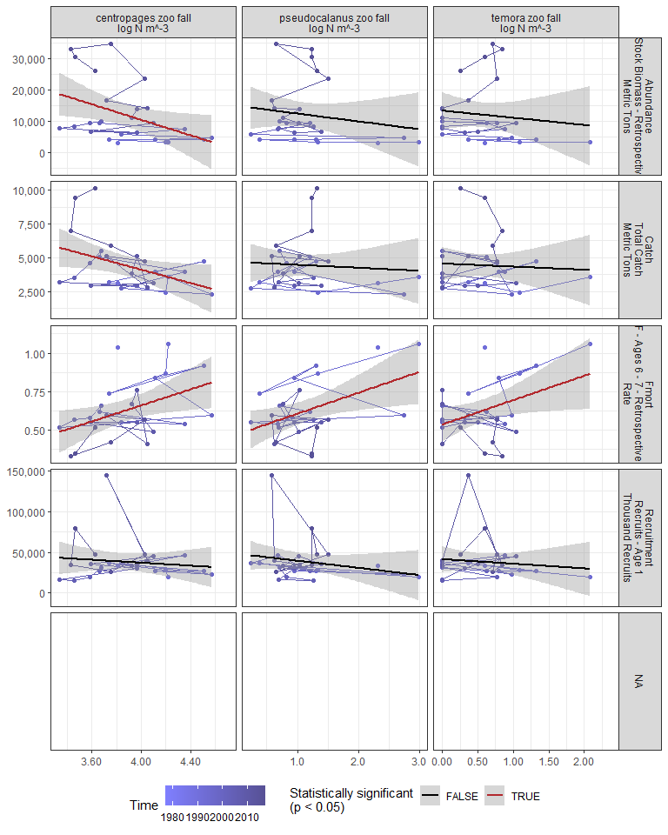

#### Regression statistics

Table 2.18: Catch vs centropages zoo fall log N m^-3

|  |  |  |  |  |
| --- | --- | --- | --- | --- |
|  | Estimate | Std. Error | t value | Pr(>|t|) |
| (Intercept) | 13953.55 | 4305.78 | 3.24 | 0.00 |
| Val | -2463.09 | 1108.03 | -2.22 | 0.04 |

|  |  |
| --- | --- |
| Name | Value |
| F-statistic | 4.94 |
| df | 1, 24 |
| R2 | 0.17 |
| R2-adj | 0.14 |

Table 2.18: Fmort vs centropages zoo fall log N m^-3

|  |  |  |  |  |
| --- | --- | --- | --- | --- |
|  | Estimate | Std. Error | t value | Pr(>|t|) |
| (Intercept) | -0.38 | 0.41 | -0.92 | 0.37 |
| Val | 0.26 | 0.11 | 2.46 | 0.02 |

|  |  |
| --- | --- |
| Name | Value |
| F-statistic | 6.03 |
| df | 1, 24 |
| R2 | 0.2 |
| R2-adj | 0.17 |

Table 2.18: Fmort vs pseudocalanus zoo fall log N m^-3

|  |  |  |  |  |
| --- | --- | --- | --- | --- |
|  | Estimate | Std. Error | t value | Pr(>|t|) |
| (Intercept) | 0.47 | 0.07 | 6.85 | 0.00 |
| Val | 0.14 | 0.05 | 2.61 | 0.02 |

|  |  |
| --- | --- |
| Name | Value |
| F-statistic | 6.81 |
| df | 1, 24 |
| R2 | 0.22 |
| R2-adj | 0.19 |

Table 2.18: Fmort vs temora zoo fall log N m^-3

|  |  |  |  |  |
| --- | --- | --- | --- | --- |
|  | Estimate | Std. Error | t value | Pr(>|t|) |
| (Intercept) | 0.54 | 0.05 | 10.08 | 0.00 |
| Val | 0.16 | 0.07 | 2.25 | 0.03 |

|  |  |
| --- | --- |
| Name | Value |
| F-statistic | 5.08 |
| df | 1, 24 |
| R2 | 0.17 |
| R2-adj | 0.14 |

Table 2.18: Abundance vs centropages zoo fall log N m^-3

|  |  |  |  |  |
| --- | --- | --- | --- | --- |
|  | Estimate | Std. Error | t value | Pr(>|t|) |
| (Intercept) | 60170.68 | 20963.85 | 2.87 | 0.01 |
| Val | -12428.16 | 5394.77 | -2.30 | 0.03 |

|  |  |
| --- | --- |
| Name | Value |
| F-statistic | 5.31 |
| df | 1, 24 |
| R2 | 0.18 |
| R2-adj | 0.15 |

### 2.3.6 Zooplankton abundance by group

#### Figures

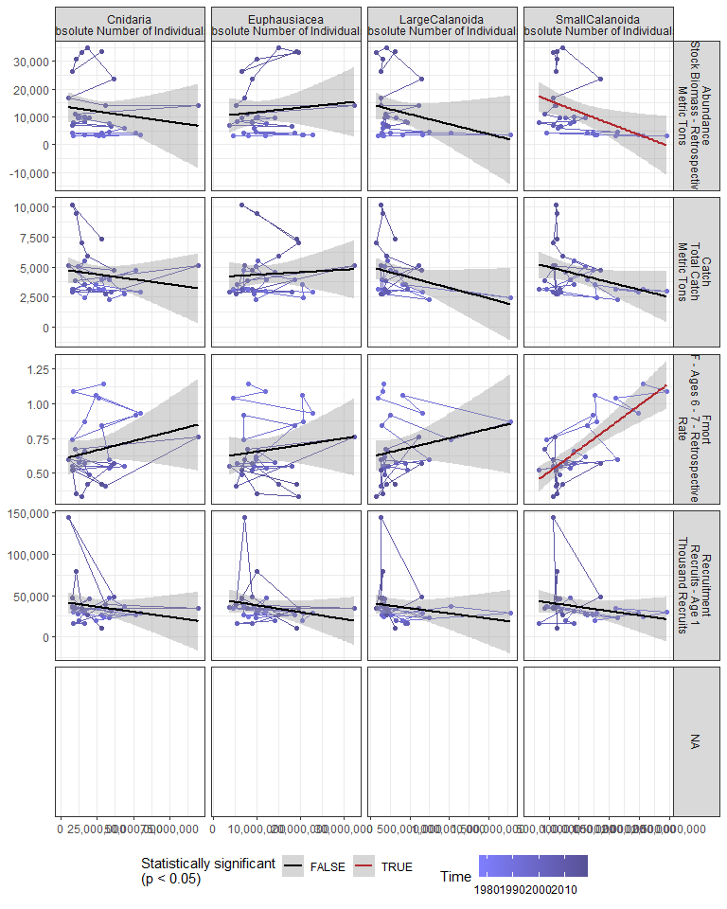

#### Regression statistics

Table 2.19: Fmort vs SmallCalanoida Absolute Number of Individuals

|  |  |  |  |  |
| --- | --- | --- | --- | --- |
|  | Estimate | Std. Error | t value | Pr(>|t|) |
| (Intercept) | 0.35 | 0.06 | 5.95 | 0 |
| Val | 0.00 | 0.00 | 5.99 | 0 |

|  |  |
| --- | --- |
| Name | Value |
| F-statistic | 35.87 |
| df | 1, 28 |
| R2 | 0.56 |
| R2-adj | 0.55 |

Table 2.19: Abundance vs SmallCalanoida Absolute Number of Individuals

|  |  |  |  |  |
| --- | --- | --- | --- | --- |
|  | Estimate | Std. Error | t value | Pr(>|t|) |
| (Intercept) | 19954.29 | 3623.31 | 5.51 | 0.00 |
| Val | 0.00 | 0.00 | -2.53 | 0.02 |

|  |  |
| --- | --- |
| Name | Value |
| F-statistic | 6.4 |
| df | 1, 28 |
| R2 | 0.19 |
| R2-adj | 0.16 |

### 2.3.7 Abundance of Calanus CV and adults

#### Figures

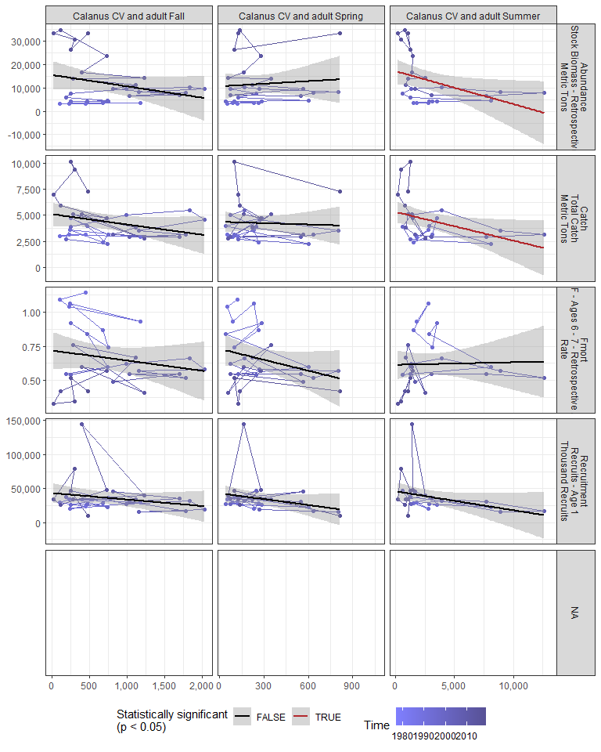

#### Regression statistics

Table 2.20: Catch vs Calanus CV and adult Summer

|  |  |  |  |  |
| --- | --- | --- | --- | --- |
|  | Estimate | Std. Error | t value | Pr(>|t|) |
| (Intercept) | 5309.07 | 523.20 | 10.15 | 0.00 |
| Val | -0.27 | 0.13 | -2.19 | 0.04 |

|  |  |
| --- | --- |
| Name | Value |
| F-statistic | 4.8 |
| df | 1, 24 |
| R2 | 0.17 |
| R2-adj | 0.13 |

Table 2.20: Abundance vs Calanus CV and adult Summer

|  |  |  |  |  |
| --- | --- | --- | --- | --- |
|  | Estimate | Std. Error | t value | Pr(>|t|) |
| (Intercept) | 17076.37 | 2668.33 | 6.40 | 0.00 |
| Val | -1.41 | 0.64 | -2.21 | 0.04 |

|  |  |
| --- | --- |
| Name | Value |
| F-statistic | 4.86 |
| df | 1, 24 |
| R2 | 0.17 |
| R2-adj | 0.13 |

### 2.3.8 Zooplankton abundance anomaly

#### Figures

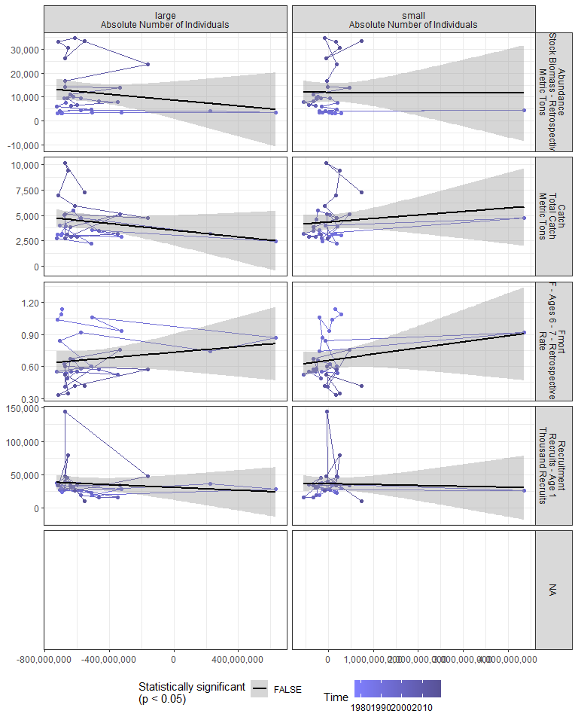

#### Regression statistics

[1] “No statistically significant data”

### 2.3.9 Zooplankton diversity index

#### Figures

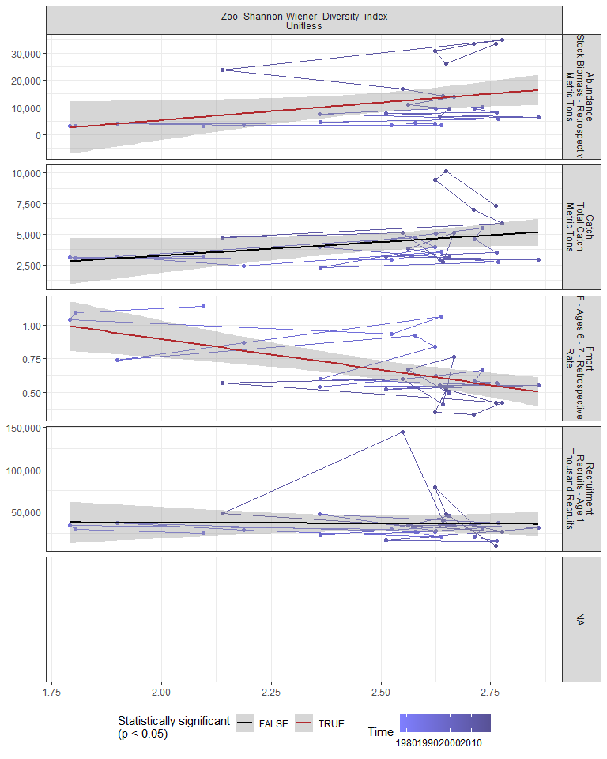

#### Regression statistics

Table 2.21: Fmort vs Zoo_Shannon-Wiener_Diversity_index Unitless

|  |  |  |  |  |
| --- | --- | --- | --- | --- |
|  | Estimate | Std. Error | t value | Pr(>|t|) |
| (Intercept) | 1.81 | 0.29 | 6.15 | 0 |
| Val | -0.46 | 0.12 | -3.92 | 0 |

|  |  |
| --- | --- |
| Name | Value |
| F-statistic | 15.35 |
| df | 1, 28 |
| R2 | 0.35 |
| R2-adj | 0.33 |

Table 2.21: Abundance vs Zoo_Shannon-Wiener_Diversity_index Unitless

|  |  |  |  |  |
| --- | --- | --- | --- | --- |
|  | Estimate | Std. Error | t value | Pr(>|t|) |
| (Intercept) | -20519.33 | 15262.63 | -1.34 | 0.19 |
| Val | 12921.78 | 6048.18 | 2.14 | 0.04 |

|  |  |
| --- | --- |
| Name | Value |
| F-statistic | 4.56 |
| df | 1, 28 |
| R2 | 0.14 |
| R2-adj | 0.11 |

### 2.3.10 Small/large copepod anomaly

#### Figures

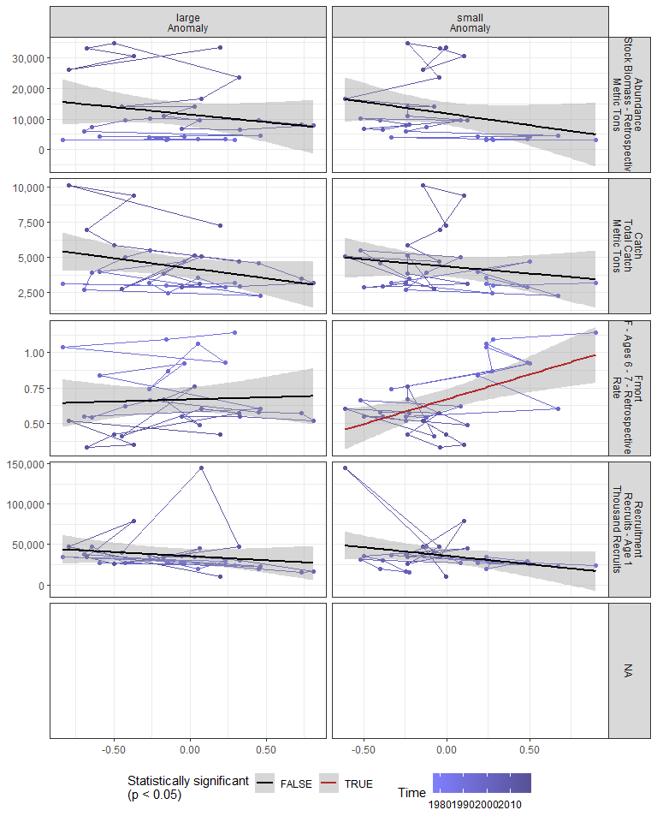

#### Regression statistics

Table 2.22: Fmort vs small Anomaly

|  |  |  |  |  |
| --- | --- | --- | --- | --- |
|  | Estimate | Std. Error | t value | Pr(>|t|) |
| (Intercept) | 0.67 | 0.03 | 19.16 | 0 |
| Val | 0.35 | 0.10 | 3.55 | 0 |

|  |  |
| --- | --- |
| Name | Value |
| F-statistic | 12.63 |
| df | 1, 28 |
| R2 | 0.31 |
| R2-adj | 0.29 |

### 2.3.11 Ichthyoplankton diversity

#### Figures

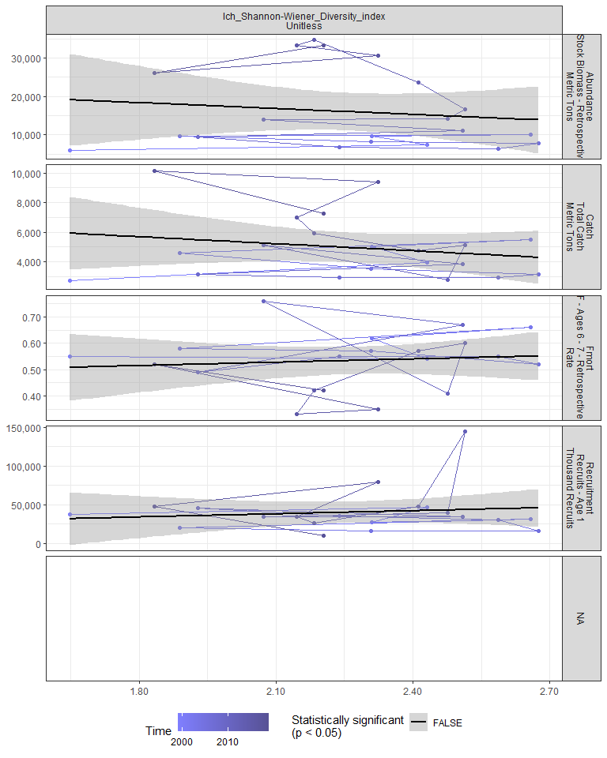

#### Regression statistics

[1] “No statistically significant data”

### 2.3.12 Forage fish abundance

#### Figures

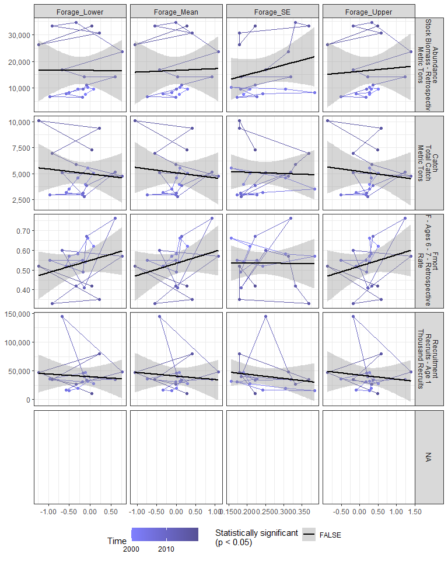

#### Regression statistics

[1] “No statistically significant data”

### 2.3.13 Species distribution

#### Figures

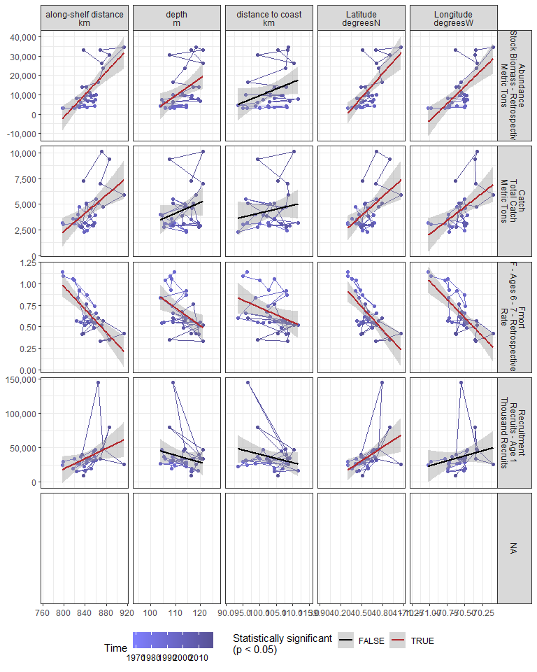

#### Regression statistics

Table 2.23: Catch vs along-shelf distance km

|  |  |  |  |  |
| --- | --- | --- | --- | --- |
|  | Estimate | Std. Error | t value | Pr(>|t|) |
| (Intercept) | -32440.24 | 10619.38 | -3.05 | 0 |
| Val | 43.55 | 12.56 | 3.47 | 0 |

|  |  |
| --- | --- |
| Name | Value |
| F-statistic | 12.03 |
| df | 1, 28 |
| R2 | 0.3 |
| R2-adj | 0.28 |

Table 2.23: Catch vs Latitude degreesN

|  |  |  |  |  |
| --- | --- | --- | --- | --- |
|  | Estimate | Std. Error | t value | Pr(>|t|) |
| (Intercept) | -243694.99 | 73883.76 | -3.30 | 0 |
| Val | 6113.67 | 1820.85 | 3.36 | 0 |

|  |  |
| --- | --- |
| Name | Value |
| F-statistic | 11.27 |
| df | 1, 28 |
| R2 | 0.29 |
| R2-adj | 0.26 |

Table 2.23: Catch vs Longitude degreesW

|  |  |  |  |  |
| --- | --- | --- | --- | --- |
|  | Estimate | Std. Error | t value | Pr(>|t|) |
| (Intercept) | 383034.16 | 116496.27 | 3.29 | 0 |
| Val | 5365.62 | 1650.75 | 3.25 | 0 |

|  |  |
| --- | --- |
| Name | Value |
| F-statistic | 10.57 |
| df | 1, 28 |
| R2 | 0.27 |
| R2-adj | 0.25 |

Table 2.23: Fmort vs along-shelf distance km

|  |  |  |  |  |
| --- | --- | --- | --- | --- |
|  | Estimate | Std. Error | t value | Pr(>|t|) |
| (Intercept) | 6.26 | 1.02 | 6.11 | 0 |
| Val | -0.01 | 0.00 | -5.46 | 0 |

|  |  |
| --- | --- |
| Name | Value |
| F-statistic | 29.86 |
| df | 1, 28 |
| R2 | 0.52 |
| R2-adj | 0.5 |

Table 2.23: Fmort vs Latitude degreesN

|  |  |  |  |  |
| --- | --- | --- | --- | --- |
|  | Estimate | Std. Error | t value | Pr(>|t|) |
| (Intercept) | 36.84 | 7.50 | 4.91 | 0 |
| Val | -0.89 | 0.18 | -4.82 | 0 |

|  |  |
| --- | --- |
| Name | Value |
| F-statistic | 23.23 |
| df | 1, 28 |
| R2 | 0.45 |
| R2-adj | 0.43 |

Table 2.23: Fmort vs Longitude degreesW

|  |  |  |  |  |
| --- | --- | --- | --- | --- |
|  | Estimate | Std. Error | t value | Pr(>|t|) |
| (Intercept) | -59.81 | 11.00 | -5.44 | 0 |
| Val | -0.86 | 0.16 | -5.50 | 0 |

|  |  |
| --- | --- |
| Name | Value |
| F-statistic | 30.24 |
| df | 1, 28 |
| R2 | 0.52 |
| R2-adj | 0.5 |

Table 2.23: Fmort vs depth m

|  |  |  |  |  |
| --- | --- | --- | --- | --- |
|  | Estimate | Std. Error | t value | Pr(>|t|) |
| (Intercept) | 3.00 | 0.81 | 3.69 | 0.00 |
| Val | -0.02 | 0.01 | -2.87 | 0.01 |

|  |  |
| --- | --- |
| Name | Value |
| F-statistic | 8.26 |
| df | 1, 28 |
| R2 | 0.23 |
| R2-adj | 0.2 |

Table 2.23: Fmort vs distance to coast km

|  |  |  |  |  |
| --- | --- | --- | --- | --- |
|  | Estimate | Std. Error | t value | Pr(>|t|) |
| (Intercept) | 2.43 | 0.82 | 2.96 | 0.01 |
| Val | -0.02 | 0.01 | -2.15 | 0.04 |

|  |  |
| --- | --- |
| Name | Value |
| F-statistic | 4.63 |
| df | 1, 28 |
| R2 | 0.14 |
| R2-adj | 0.11 |

Table 2.23: Recruitment vs along-shelf distance km

|  |  |  |  |  |
| --- | --- | --- | --- | --- |
|  | Estimate | Std. Error | t value | Pr(>|t|) |
| (Intercept) | -276515.83 | 146132.92 | -1.89 | 0.07 |
| Val | 369.82 | 172.79 | 2.14 | 0.04 |

|  |  |
| --- | --- |
| Name | Value |
| F-statistic | 4.58 |
| df | 1, 28 |
| R2 | 0.14 |
| R2-adj | 0.11 |

Table 2.23: Recruitment vs Latitude degreesN

|  |  |  |  |  |
| --- | --- | --- | --- | --- |
|  | Estimate | Std. Error | t value | Pr(>|t|) |
| (Intercept) | -2652924.3 | 960154.03 | -2.76 | 0.01 |
| Val | 66271.8 | 23662.84 | 2.80 | 0.01 |

|  |  |
| --- | --- |
| Name | Value |
| F-statistic | 7.84 |
| df | 1, 28 |
| R2 | 0.22 |
| R2-adj | 0.19 |

Table 2.23: Abundance vs along-shelf distance km

|  |  |  |  |  |
| --- | --- | --- | --- | --- |
|  | Estimate | Std. Error | t value | Pr(>|t|) |
| (Intercept) | -233747.67 | 47298.30 | -4.94 | 0 |
| Val | 290.54 | 55.93 | 5.20 | 0 |

|  |  |
| --- | --- |
| Name | Value |
| F-statistic | 26.99 |
| df | 1, 28 |
| R2 | 0.49 |
| R2-adj | 0.47 |

Table 2.23: Abundance vs Latitude degreesN

|  |  |  |  |  |
| --- | --- | --- | --- | --- |
|  | Estimate | Std. Error | t value | Pr(>|t|) |
| (Intercept) | -1648214.25 | 332019.98 | -4.96 | 0 |
| Val | 40912.92 | 8182.58 | 5.00 | 0 |

|  |  |
| --- | --- |
| Name | Value |
| F-statistic | 25 |
| df | 1, 28 |
| R2 | 0.47 |
| R2-adj | 0.45 |

Table 2.23: Abundance vs Longitude degreesW

|  |  |  |  |  |
| --- | --- | --- | --- | --- |
|  | Estimate | Std. Error | t value | Pr(>|t|) |
| (Intercept) | 2526922.83 | 532448.45 | 4.75 | 0 |
| Val | 35638.27 | 7544.77 | 4.72 | 0 |

|  |  |
| --- | --- |
| Name | Value |
| F-statistic | 22.31 |
| df | 1, 28 |
| R2 | 0.44 |
| R2-adj | 0.42 |

Table 2.23: Abundance vs depth m

|  |  |  |  |  |
| --- | --- | --- | --- | --- |
|  | Estimate | Std. Error | t value | Pr(>|t|) |
| (Intercept) | -89929.71 | 36852.43 | -2.44 | 0.02 |
| Val | 903.73 | 326.81 | 2.77 | 0.01 |

|  |  |
| --- | --- |
| Name | Value |
| F-statistic | 7.65 |
| df | 1, 28 |
| R2 | 0.21 |
| R2-adj | 0.19 |

## 2.4 Larvae and YOY indicators

### 2.4.1 Recruitment

#### Figures

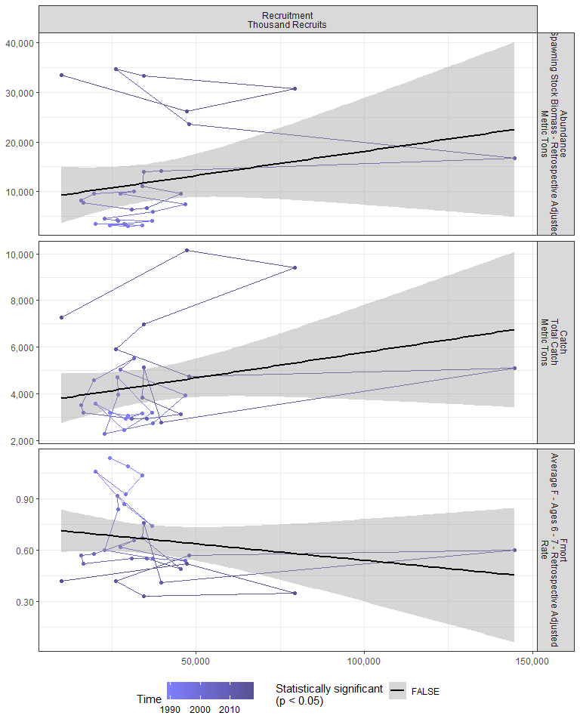

#### Regression statistics

[1] “No statistically significant data”

### 2.4.2 Larval growth

## 2.5 Juvenile indicators

### 2.5.1 Length-age curves

### 2.5.2 Condition

### 2.5.3 CPUE

## 2.6 Adult indicators

### 2.6.1 Abundance

#### Figures

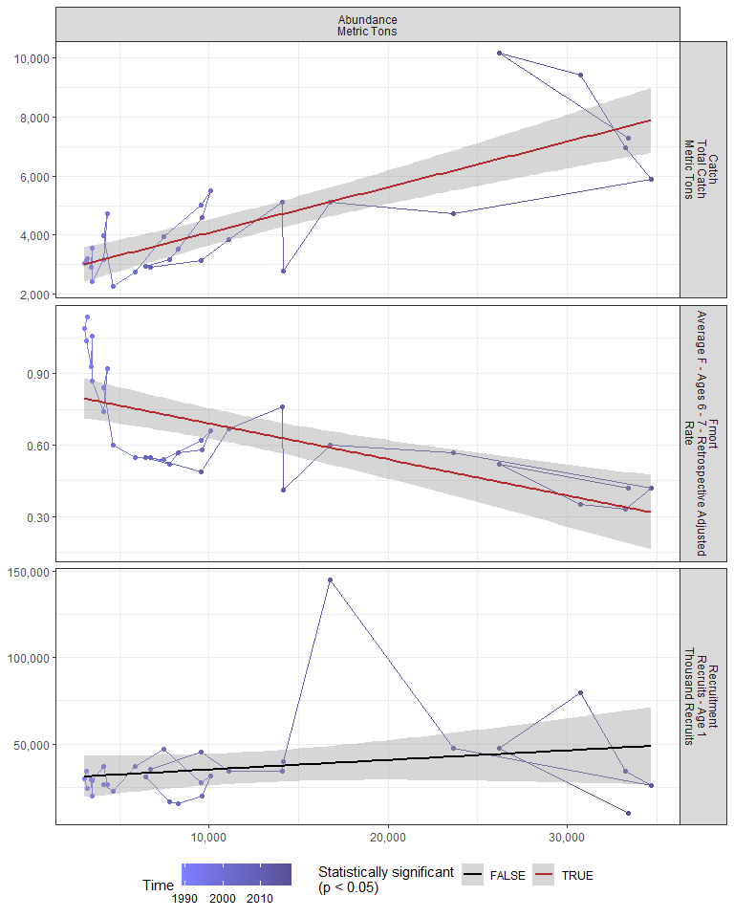

#### Regression statistics

Table 2.24: Catch vs Abundance Metric Tons

|  |  |  |  |  |
| --- | --- | --- | --- | --- |
|  | Estimate | Std. Error | t value | Pr(>|t|) |
| (Intercept) | 2543.26 | 333.57 | 7.62 | 0 |
| Val | 0.15 | 0.02 | 7.18 | 0 |

|  |  |
| --- | --- |
| Name | Value |
| F-statistic | 51.55 |
| df | 1, 28 |
| R2 | 0.65 |
| R2-adj | 0.64 |

Table 2.24: Fmort vs Abundance Metric Tons

|  |  |  |  |  |
| --- | --- | --- | --- | --- |
|  | Estimate | Std. Error | t value | Pr(>|t|) |
| (Intercept) | 0.84 | 0.05 | 17.68 | 0 |
| Val | 0.00 | 0.00 | -4.93 | 0 |

|  |  |
| --- | --- |
| Name | Value |
| F-statistic | 24.33 |
| df | 1, 28 |
| R2 | 0.46 |
| R2-adj | 0.45 |

### 2.6.2 Mean age of spawning stock

### 2.6.3 Age distribution

### 2.6.4 Length-age curves

### 2.6.5 Condition

#### Figures

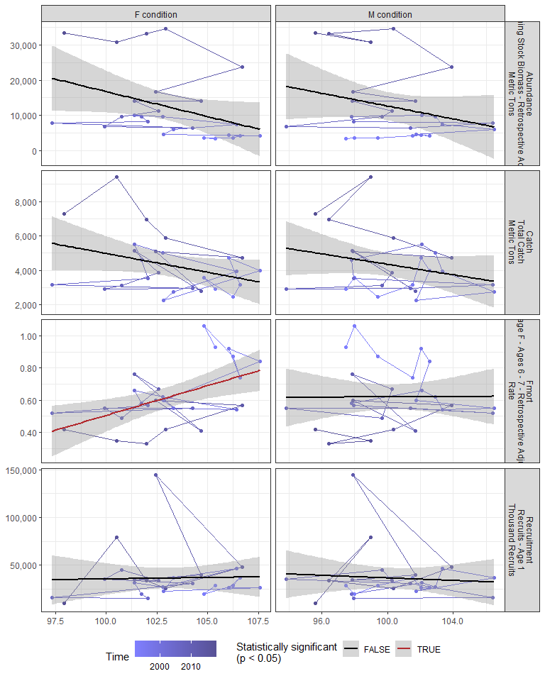

#### Regression statistics

Table 2.25: Fmort vs F condition

|  |  |  |  |  |
| --- | --- | --- | --- | --- |
|  | Estimate | Std. Error | t value | Pr(>|t|) |
| (Intercept) | -3.18 | 1.23 | -2.58 | 0.02 |
| Val | 0.04 | 0.01 | 3.08 | 0.01 |

|  |  |
| --- | --- |
| Name | Value |
| F-statistic | 9.5 |
| df | 1, 24 |
| R2 | 0.28 |
| R2-adj | 0.25 |

### 2.6.6 Stomach fullness

#### Figures

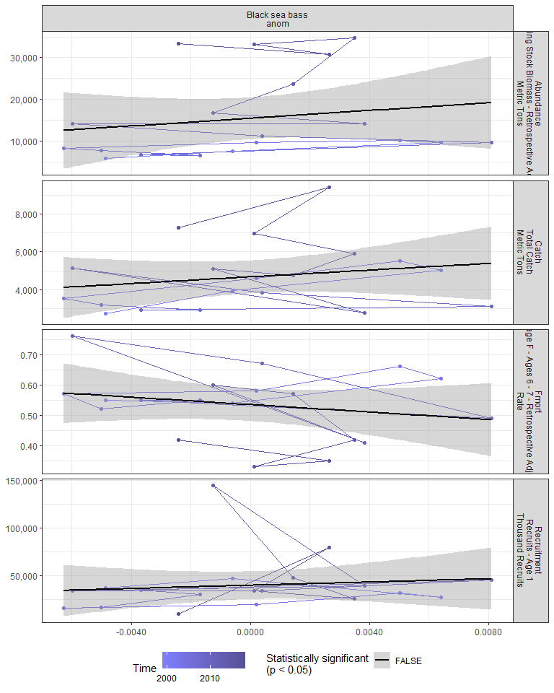

#### Regression statistics

[1] “No statistically significant data”

### 2.6.7 Center of gravity and area occupied

## 2.7 Socioeconomic indicators

### 2.7.1 CPUE by catch strategy

### 2.7.2 Recreational CPUE

#### Figures

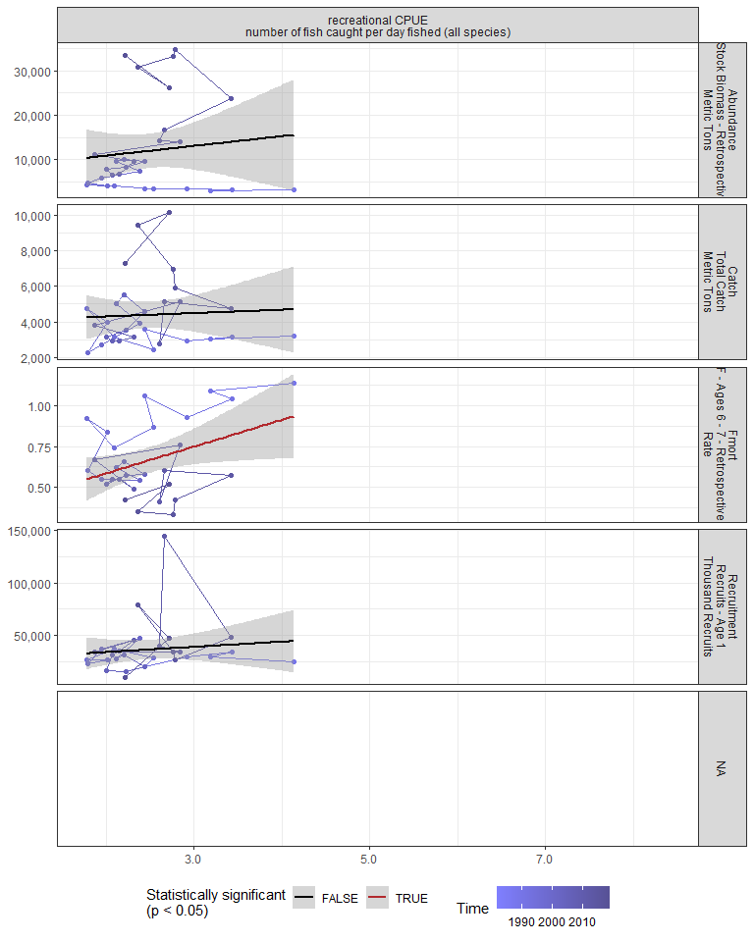

#### Regression statistics

Table 2.26: Fmort vs recreational CPUE number of fish caught per day fished (all species)

|  |  |  |  |  |
| --- | --- | --- | --- | --- |
|  | Estimate | Std. Error | t value | Pr(>|t|) |
| (Intercept) | 0.26 | 0.18 | 1.39 | 0.17 |
| Val | 0.16 | 0.07 | 2.27 | 0.03 |

|  |  |
| --- | --- |
| Name | Value |
| F-statistic | 5.14 |
| df | 1, 28 |
| R2 | 0.16 |
| R2-adj | 0.13 |

# 3 Summary of statistically significant indicators

## 3.1 Abundance

|  |  |  |  |  |
| --- | --- | --- | --- | --- |
| Indicator | Number of data points | Slope | P-value | R2_adj |
| Time | 30 | 1000 | 9.3e-10 | 0.73 |
| cumulative intensity |  |  |  |  |
| degrees C | 26 | 51 | 0.0016 | 0.32 |
| maximum intensity |  |  |  |  |
| degrees C | 26 | 12000 | 0.012 | 0.2 |
| GLORYS bottom temp anomaly |  |  |  |  |
| degreesC | 26 | 5500 | 0.011 | 0.21 |
| long-term sst |  |  |  |  |
| degreesC | 30 | 10000 | 2.6e-05 | 0.46 |
| fall OI SST Anomaly |  |  |  |  |
| degreesC | 30 | 8600 | 0.00035 | 0.35 |
| summer OI SST Anomaly |  |  |  |  |
| degreesC | 30 | 8900 | 3.6e-05 | 0.44 |
| spring OI SST Anomaly |  |  |  |  |
| degreesC | 30 | 5700 | 0.015 | 0.16 |
| fall |  |  |  |  |

OI SST Anomaly Black sea bass north spring degreesC |30 |7400 |9.7e-05 |0.4 | |fall OI SST Anomaly Black sea bass south spring degreesC |30 |7100 |0.0042 |0.23 | |fall OI SST Anomaly Black sea bass spring degreesC |30 |8000 |0.00024 |0.36 | |summer OI SST Anomaly Black sea bass north spring degreesC |30 |8100 |3.8e-05 |0.44 | |summer OI SST Anomaly Black sea bass south spring degreesC |30 |8200 |0.00062 |0.32 | |summer OI SST Anomaly Black sea bass spring degreesC |30 |8800 |5.3e-05 |0.43 | |winter OI SST Anomaly Black sea bass north spring degreesC |30 |4400 |0.04 |0.11 | |spring OI SST Anomaly Black sea bass north spring degreesC |30 |6500 |0.015 |0.17 | |spring OI SST Anomaly Black sea bass spring degreesC |30 |5000 |0.05 |0.1 | |tke winter J/kg |30 |67000 |0.0038 |0.24 | |hcly summer m2/sec2 |30 |-630 |0.015 |0.16 | |northern_latitude |30 |11000 |0.00043 |0.34 | |spring Black sea bass south spring gC m-2 d-1 |21 |43000 |0.012 |0.25 | |spring Black sea bass spring gC m-2 d-1 |21 |47000 |0.024 |0.2 | |centropages zoo fall log N m^-3 |29 |-12000 |0.03 |0.15 | |SmallCalanoida Absolute Number of Individuals |30 |-8.3e-06 |0.017 |0.16 | |Calanus CV and adult Summer |27 |-1.4 |0.037 |0.13 | |Zoo_Shannon-Wiener_Diversity_index Unitless |30 |13000 |0.042 |0.11 | |along-shelf distance km |30 |290 |1.6e-05 |0.47 | |Latitude degreesN |30 |41000 |2.8e-05 |0.45 | |Longitude degreesW |30 |36000 |5.9e-05 |0.42 | |depth m |30 |900 |0.01 |0.19 |

### 3.1.1 Generalized linear model

This is an exploratory fit of a poisson GLM. Initial covariates were included based on statistical significance at a Bonferroni-corrected alpha in the linear correlations shown in this report. Final covariates were chosen by forward stepwise AIC selection of additive GLMs.

|  |  |  |  |  |
| --- | --- | --- | --- | --- |
| rnames | Estimate | Std. Error | z value | Pr(>|z|) |
| (Intercept) | -593 | 11.9 | -50 | 0 |
| long_term_sst_degreesC | 0.129 | 0.00644 | 20 | 7.86e-89 |
| Longitude_degreesW | -25 | 0.467 | -53.4 | 0 |
| summer_OI_SST_Anomaly_degreesC | 4.53 | 0.0381 | 119 | 0 |
| summer_OI_SST_Anomaly_Black_sea_bass_south_spring_degreesC | -2.98 | 0.0249 | -120 | 0 |
| summer_OI_SST_Anomaly_Black_sea_bass_north_spring_degreesC | -1.29 | 0.0167 | -77.2 | 0 |
| northern_latitude | 0.219 | 0.00633 | 34.7 | 3.45e-263 |
| fall_OI_SST_Anomaly_degreesC | 0.578 | 0.056 | 10.3 | 5.69e-25 |
| fall_OI_SST_Anomaly_Black_sea_bass_spring_degreesC | -0.412 | 0.0741 | -5.56 | 2.73e-08 |
| along_shelf_distance_km | 0.459 | 0.00826 | 55.6 | 0 |
| Latitude_degreesN | -38.4 | 0.703 | -54.7 | 0 |
| fall_OI_SST_Anomaly_Black_sea_bass_north_spring_degreesC | -0.152 | 0.0217 | -7 | 2.65e-12 |

Dropped coefficients: summer_OI_SST_Anomaly_Black_sea_bass_spring_degreesC

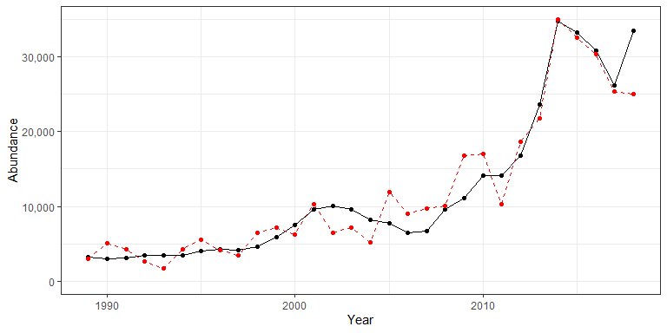

## 3.2 Recruitment

|  |  |  |  |  |
| --- | --- | --- | --- | --- |
| Indicator | Number of data points | Slope | P-value | R2_adj |
| T_mean | 26 | 44000 | 3.4e-05 | 0.5 |
| T_min | 26 | 21000 | 0.00018 | 0.43 |
| T_peak | 26 | 31000 | 5e-05 | 0.48 |
| V_max | 26 | -410000 | 0.019 | 0.17 |
| cumulative intensity |  |  |  |  |
| degrees C | 26 | 150 | 7.5e-05 | 0.46 |
| GLORYS bottom temp anomaly |  |  |  |  |
| degreesC | 26 | 17000 | 0.00085 | 0.35 |
| long-term sst |  |  |  |  |
| degreesC | 30 | 22000 | 0.00017 | 0.38 |
| summer OI SST Anomaly |  |  |  |  |
| degreesC | 30 | 13000 | 0.023 | 0.14 |
| spring OI SST Anomaly |  |  |  |  |
| degreesC | 30 | 18000 | 0.00089 | 0.31 |
| winter OI SST Anomaly |  |  |  |  |
| degreesC | 30 | 18000 | 2.8e-05 | 0.45 |
| fall |  |  |  |  |

OI SST Anomaly Black sea bass north spring degreesC |30 |12000 |0.012 |0.18 | |fall OI SST Anomaly Black sea bass spring degreesC |30 |11000 |0.047 |0.1 | |summer OI SST Anomaly Black sea bass north spring degreesC |30 |12000 |0.021 |0.15 | |summer OI SST Anomaly Black sea bass south spring degreesC |30 |13000 |0.032 |0.12 | |summer OI SST Anomaly Black sea bass spring degreesC |30 |13000 |0.019 |0.15 | |winter OI SST Anomaly Black sea bass north spring degreesC |30 |20000 |6.5e-06 |0.5 | |spring OI SST Anomaly Black sea bass north spring degreesC |30 |22000 |0.00023 |0.37 | |spring OI SST Anomaly Black sea bass south spring degreesC |30 |11000 |0.02 |0.15 | |spring OI SST Anomaly Black sea bass spring degreesC |30 |19000 |0.0012 |0.29 | |winter OI SST Anomaly Black sea bass south spring degreesC |30 |15000 |0.00084 |0.31 | |winter OI SST Anomaly Black sea bass spring degreesC |30 |19000 |3.9e-05 |0.44 | |northern_latitude |30 |16000 |0.049 |0.1 | |ANNUAL PPD MEDIAN gCarbon/m^2/Day |21 |3e+05 |0.033 |0.18 | |ANNUAL PPD RATIO ANOMALY |21 |260000 |0.01 |0.26 | |summer Black sea bass north spring gC m-2 d-1 |21 |1e+05 |0.028 |0.19 | |winter Black sea bass north spring gC m-2 d-1 |21 |510000 |0.0057 |0.3 | |winter Black sea bass south spring gC m-2 d-1 |21 |430000 |0.002 |0.37 | |winter Black sea bass spring gC m-2 d-1 |21 |5e+05 |0.0024 |0.36 | |pseudocalanus zoo spring log N m^-3 |29 |-15000 |0.0067 |0.26 | |temora zoo spring log N m^-3 |29 |-15000 |0.05 |0.13 | |along-shelf distance km |30 |370 |0.041 |0.11 | |Latitude degreesN |30 |66000 |0.0091 |0.19 |

### 3.2.1 Generalized linear model

This is an exploratory fit of a poisson GLM. Initial covariates were included based on statistical significance at a Bonferroni-corrected alpha in the linear correlations shown in this report. Final covariates were chosen by forward stepwise AIC selection of additive GLMs.

|  |  |  |  |  |
| --- | --- | --- | --- | --- |
| rnames | Estimate | Std. Error | z value | Pr(>|z|) |
| (Intercept) | 13.1 | 0.0795 | 165 | 0 |
| winter_OI_SST_Anomaly_Black_sea_bass_north_spring_degreesC | 1.06 | 0.0111 | 95.6 | 0 |
| spring_OI_SST_Anomaly_Black_sea_bass_north_spring_degreesC | 0.0557 | 0.007 | 7.95 | 1.9e-15 |
| winter_OI_SST_Anomaly_Black_sea_bass_spring_degreesC | -2.02 | 0.0181 | -112 | 0 |
| winter_OI_SST_Anomaly_degreesC | 1.38 | 0.0127 | 108 | 0 |
| long_term_sst_degreesC | -0.376 | 0.00743 | -50.7 | 0 |
| spring_OI_SST_Anomaly_Black_sea_bass_spring_degreesC | -0.475 | 0.0281 | -16.9 | 2.7e-64 |
| GLORYS_bottom_temp_anomaly_degreesC | 0.116 | 0.00338 | 34.3 | 1.91e-258 |
| T_min | -0.246 | 0.00538 | -45.6 | 0 |
| T_peak | 0.355 | 0.0101 | 35.3 | 1.19e-272 |
| spring_OI_SST_Anomaly_degreesC | 0.621 | 0.025 | 24.8 | 6.58e-136 |
| cumulative_intensity_degrees_C | 0.000179 | 1.62e-05 | 11.1 | 1.7e-28 |

[1] ""

Dropped coefficients:

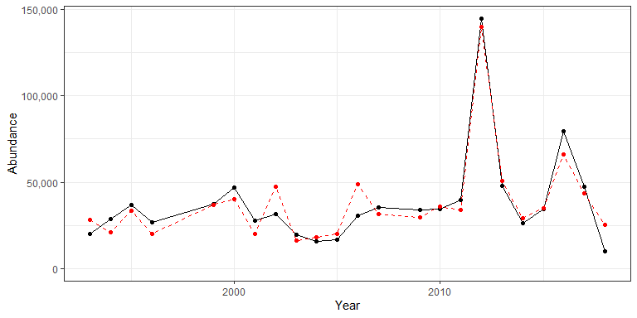

## 3.3 Catch

|  |  |  |  |  |
| --- | --- | --- | --- | --- |
| Indicator | Number of data points | Slope | P-value | R2_adj |
| Time | 30 | 150 | 5.2e-05 | 0.43 |
| cumulative intensity |  |  |  |  |
| degrees C | 26 | 7.8 | 0.015 | 0.19 |
| long-term sst |  |  |  |  |
| degreesC | 30 | 1600 | 0.00096 | 0.3 |
| fall OI SST Anomaly |  |  |  |  |
| degreesC | 30 | 1300 | 0.0093 | 0.19 |
| summer OI SST Anomaly |  |  |  |  |
| degreesC | 30 | 1200 | 0.0099 | 0.19 |
| fall |  |  |  |  |

OI SST Anomaly Black sea bass north spring degreesC |30 |1000 |0.0074 |0.2 | |fall OI SST Anomaly Black sea bass south spring degreesC |30 |1100 |0.029 |0.13 | |fall OI SST Anomaly Black sea bass spring degreesC |30 |1200 |0.0092 |0.19 | |summer OI SST Anomaly Black sea bass north spring degreesC |30 |1000 |0.016 |0.16 | |summer OI SST Anomaly Black sea bass south spring degreesC |30 |1100 |0.027 |0.13 | |summer OI SST Anomaly Black sea bass spring degreesC |30 |1100 |0.015 |0.17 | |winter OI SST Anomaly Black sea bass north spring degreesC |30 |970 |0.018 |0.16 | |stratification (0-50 m) kg m^-3 |29 |-130000 |0.033 |0.14 | |tke winter J/kg |30 |10000 |0.025 |0.14 | |gulf stream index latitude anomaly |26 |1100 |0.049 |0.12 | |northern_latitude |30 |1400 |0.03 |0.13 | |southern_latitude |30 |2100 |0.046 |0.1 | |summer Black sea bass south spring gC m-2 d-1 |21 |5700 |0.041 |0.16 | |summer Black sea bass spring gC m-2 d-1 |21 |7500 |0.034 |0.17 | |centropages zoo fall log N m^-3 |29 |-2500 |0.036 |0.14 | |Calanus CV and adult Summer |27 |-0.27 |0.038 |0.13 | |along-shelf distance km |30 |44 |0.0017 |0.28 | |Latitude degreesN |30 |6100 |0.0023 |0.26 | |Longitude degreesW |30 |5400 |0.003 |0.25 | |Abundance Metric Tons |30 |0.15 |8.2e-08 |0.64 |

## 3.4 Fmort

|  |  |  |  |  |
| --- | --- | --- | --- | --- |
| Indicator | Number of data points | Slope | P-value | R2_adj |
| Time | 30 | -0.022 | 3.3e-09 | 0.71 |
| Warm Core Rings |  |  |  |  |
| n | 30 | -0.016 | 0.00045 | 0.34 |
| cumulative intensity |  |  |  |  |
| degrees C | 26 | -0.00096 | 0.0088 | 0.22 |
| maximum intensity |  |  |  |  |
| degrees C | 26 | -0.23 | 0.024 | 0.16 |
| GLORYS bottom temp anomaly |  |  |  |  |
| degreesC | 26 | -0.091 | 0.013 | 0.2 |
| long-term sst |  |  |  |  |
| degreesC | 30 | -0.2 | 6e-04 | 0.33 |
| fall OI SST Anomaly |  |  |  |  |
| degreesC | 30 | -0.2 | 0.00023 | 0.37 |
| summer OI SST Anomaly |  |  |  |  |
| degreesC | 30 | -0.17 | 0.00072 | 0.32 |
| fall |  |  |  |  |

OI SST Anomaly Black sea bass north spring degreesC |30 |-0.15 |0.00042 |0.34 | |fall OI SST Anomaly Black sea bass south spring degreesC |30 |-0.17 |0.0013 |0.29 | |fall OI SST Anomaly Black sea bass spring degreesC |30 |-0.17 |0.00034 |0.35 | |summer OI SST Anomaly Black sea bass north spring degreesC |30 |-0.15 |0.00087 |0.31 | |summer OI SST Anomaly Black sea bass south spring degreesC |30 |-0.16 |0.0026 |0.26 | |summer OI SST Anomaly Black sea bass spring degreesC |30 |-0.17 |0.00078 |0.31 | |tke winter J/kg |30 |-1.6 |0.0022 |0.26 | |total wind speed winter J/kg |30 |-0.16 |0.029 |0.13 | |hcly summer m2/sec2 |30 |0.017 |0.0025 |0.26 | |tke summer J/kg |30 |-3.7 |0.032 |0.12 | |northern_latitude |30 |-0.22 |0.0023 |0.26 | |southern_latitude |30 |-0.3 |0.014 |0.17 | |centropages zoo fall log N m^-3 |29 |0.26 |0.022 |0.17 | |pseudocalanus zoo fall log N m^-3 |29 |0.14 |0.015 |0.19 | |temora zoo fall log N m^-3 |29 |0.16 |0.034 |0.14 | |SmallCalanoida Absolute Number of Individuals |30 |3.2e-10 |1.9e-06 |0.55 | |Zoo_Shannon-Wiener_Diversity_index Unitless |30 |-0.46 |0.00052 |0.33 | |small Anomaly |30 |0.35 |0.0014 |0.29 | |along-shelf distance km |30 |-0.0066 |7.8e-06 |0.5 | |Latitude degreesN |30 |-0.89 |4.5e-05 |0.43 | |Longitude degreesW |30 |-0.86 |7.1e-06 |0.5 | |depth m |30 |-0.021 |0.0076 |0.2 | |distance to coast km |30 |-0.017 |0.04 |0.11 | |Abundance Metric Tons |30 |-1.5e-05 |3.3e-05 |0.45 | |F condition |26 |0.037 |0.0051 |0.25 | |recreational CPUE number of fish caught per day fished (all species) |30 |0.16 |0.031 |0.13 |